The capital structure of enterprises in the furniture industry cluster

Martina Harc
Institute for Scientific and Artistic Work in Osijek, Croatian Academy of Sciences and Arts, Croatia
harcm@hazu.hr
Martina Briš Alić
Faculty of Economics in Osijek, J.J. Strossmayer University of Osijek, Croatia
mbris@efos.hr

Summary

The European Union is recovering from its longest ever recession. Even the recovery remains modes the EU is on the right way aiming to release strategies for post-crisis sustainable growth and modernisation of Europe's industrial base and the promotion of a competitive framework for EU industry. Therefore, in January 2014, the Croatian Ministry of Economy published the Industrial Strategy of the Republic of Croatia 2014– 2020 in which the industry of furniture manufacture was assigned a strategic role, and the sub-area C31.0 – Manufacture of Furniture, was classified as one of key industrial sub-areas or Initiators. Aiming to release full potential of SMEs growth, the European Commission, among other prior objectives highlighted potential of clusters as being able to facilitate cross-sectoral and cross-border collaboration, helping SMEs to grow. In this regard, focus of this research is on furniture industry cluster from section C - Manufacturing, division 31 - Manufacture of furniture, class 31.09 - Manufacture of other furniture. Accordingly, using spatial autocorrelation enterprises from class 31.09 - Manufacture of other furniture are clustered by determinants geographical location (latitude and longitude), the number of employees, average net salary and value added into seven clusters. In order to examine the relationships between variables which formed clusters and capital structure, regression analysis is applied.
Key words: furniture industry, cluster, Small and medium sized enterprises (SMEs), capital structure

The capital structure of enterprises in the furniture industry cluster

- Introduction
The European Union is recovering from its longest ever recession. Even the recovery remains modes the EU is on the right track striving to create basis for post-crisis sustainable growth and modernisation of Europe's industrial base and the promotion of a competitive framework for EU industry. Still, the economic challenges that EU member countries are facing remain important. The above mentioned is evidenced by Europa 2020 strategy (European Commission 2010) under Flagship Initiative: "An industrial policy for the globalisation era" where Commission among other objectives, seeks to improve the business environment, especially for SMEs through the promotion of clusters and improving affordable access to finance developing a strong and sustainable globally competitive industrial base. Furthermore, in renewed industrial strategy outlined in 2012 Communication, the Commission seeks to reverse the declining role of industry in Europe from its level of 16%3 of GDP in 2012 to as much as 20% by 2020. Following that ambitious goal, in 2014 the European Commission adopted a new Communication, 'For a European Industrial Renaissance' setting out the Commission’s key priorities for industrial policy and more important stressing the importance of full and effective implementation of industrial policy in the EU. EU industrial policy has paid much attention to small and medium enterprises, emphasising their importance in EU economy mainstreamed them into policy actions. Aiming to release full potential of SMEs growth, the Communication among other prior objectives highlighted potential of clusters as being able to facilitate cross-sectoral and cross-border collaboration, helping SMEs to grow. But to be effective, policy actions must be well co-ordinated and consistent from regional to the EU level. Therefore, in in January 2014, the Croatian Ministry of Economy published the Industrial Strategy of the Republic of Croatia 2014– 2020 with the aim of repositioning the identified strategic activities in the global value chain towards the development of activities that create added value. In doing so, the Strategy divided and arranged subareas into five groups on the basis of valuation models and ranking. The valuation model was based on three criteria used for the evaluation of sub-areas, grouping the sub-areas and their ranking within the group: profitability (EBITDA per person employed), export orientation, and size of the sub-area (defined by the number of persons employed in a specific sub-area) in which the industry of furniture manufacture was assigned a strategic role, and the sub-area of the wood sector C31.0 – Manufacture of Furniture, was classified as one of key industrial sub-area or Initiator (Družić, Basarac Sertić, 2015). Additionally, the furniture sector stands to benefit from above mentioned Flagship An industrial policy for the globalisation era placeing emphasis on the role played by the European manufacturing industry as a driver of economic growth and employment levels in Europe (CEPS, CSIL, The EU furniture market situation and a possible furniture products initiative, 2014). In this regard, focus of this research will be on furniture industry cluster from section C - Manufacturing, division 31 - Manufacture of furniture, class 31.09 - Manufacture of other furniture. Enterprises are clustered by geographical location (latitude and longitude), the number of employees, average net salary (in HRK) and value added (in HRK). The empirical analysis was conducted on a sample of 287 enterprises. More specifically, small, medium and two large enterprises. Focus in this research is on small and medium enterprises because most of the observed enterprises are small (275), ten are medium-sized companies and only two are large (Prima commerce d.o.o. and Tvin d.o.o.).
The rest of this paper is structured as follows. The next section, key sectoral facts in the context of the furniture industry in Croatia, comes after this introduction. Capital structure is discussed in section 3. Section 4 describes data and introduce the methodology adopted. Empirical results are presented in section 5. Finally, section 6 concludes and discussion.

- Key sectoral facts in the context of the furniture industry in Croatia

The furniture industry is a labour-intensive and dynamic sector dominated by small and medium-sized enterprises (SMEs) and micro firms. EU furniture manufacturers have a good reputation worldwide thanks to their creative capacity for new designs and responsiveness to new demands. The industry is able to combine new technologies and innovation with cultural heritage and style, and provides jobs for highly skilled workers (European Commission). As mentioned in introduction, focus in this research is on enterprises from section C - Manufacturing, division 31 - Manufacture of furniture, class 31.09 - Manufacture of other furniture, classified by activity based on the National Classification of Activities (NKD 2007, OG 58/2007) grouped into seven furniture industry clusters. Clusters are groups of specialised enterprises – often SMEs – and other related supporting actors that cooperate closely together in a particular location. In working together SMEs can be more innovative, create more jobs and register more international trademarks and patents than they would alone (European Commission). According to newest data, 3 000 strong clusters across Europe account for more than 54 million jobs and 45% of all traded industries’ wages (23% of the overall economy). Wages in strong clusters are close to 3% higher than in industries not located in such regional hotspots, and the wage gap towards both other traded industries and the overall economy is growing (European Cluster Panorama 2016, November 2016). Clusters “are cross-sectoral by their nature, as they refer to a concentration of related industries and institutions, and thus, they can be platforms for innovation and industrial change (…). They transform and reinvent themselves in response to changes in the external environment or changes initiated within the cluster, which can be amplified through positive feedback between this external environment and the cluster itself” (European Cluster Trends, Preliminary Report, European Commission, Brussels 2014, p. 12). Furthermore, according to European Cluster Panorama 2016, cluster performance are measured using two-stage approach. In the first stage, ‘strong clusters’ are identified by specialization. According to measure of specialization, Croatia's location quotient in furniture industry is respectively 1.394, meaning that Croatia is not 100 per cent specialized in the given industry, but is on the right track (Figure1). Further progress is essential.

Figure 1: Specialisation (Location Quotient) of Croatia in a given industry relative to Europe

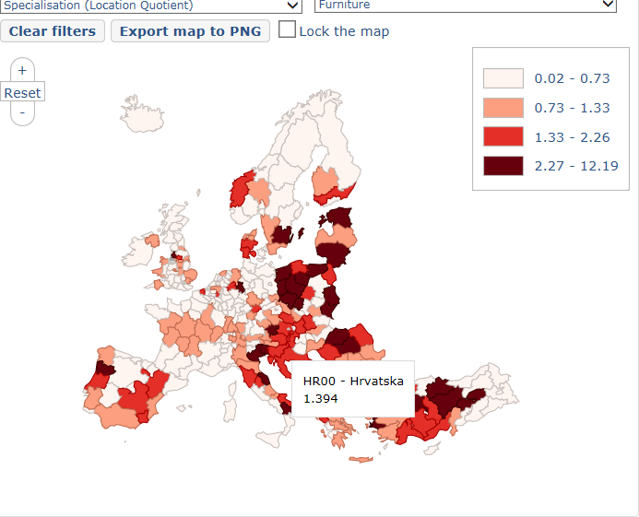

Source: The Cluster Mapping tool, European Commission

In the second stage, ʽfour starʼ methodology is used to capture how well a location is leveraging the presence of a cluster.

Figure 2: Four star methodology in a given industry relative to Europe

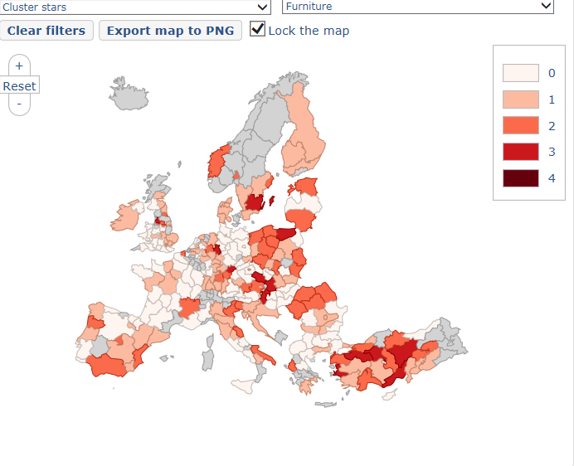

Source: The Cluster Mapping tool, European Commission

In Figure 2, furniture industry cluster in Croatia is ranked by 1 meaning that Croatia's furniture industry cluster falls into the top 20% of European regions because location falls in any of the four dimensions: size, specialisation, productivity, and growth.

- Capital structure in the context of the furniture industry cluster

Capital structure is one of the most intriguing fields in financial management. Since the publication of the famous paper of Modigliani and Miller in 1958, the relation between debt and equity has generated a great interest among researchers. Capital structure researches are focused toward two theories: trade off theory (TOT) and pecking order theory (POT). From the theoretical point of view, existing empirical studies widely used two models of capital structure: the trade-off theory and the pecking order theory. Trade-off theory implies that a company's capital structure decisions involve a trade-off between the tax benefits of debt financing and the costs of financial distress. The pecking order theory points out that there is a certain order in financing, starting from retained earnings as a primary source of internal financing, then moving to debt and using equity only as the last resort. Each of these theories suggests how certain determinants affect capital structure. According to Shamshur (2010) capital structure theories offer a number of determinants that are responsible for various impacts on capital structure, while the empirical literature tend to find evidence that firms behave in accordance with the theoretical predictions. Mostly they focus on those determinants which are more likely to have a major role on leverage decisions. Although there have been various studies analysing capital structure, it is still debated what the determinants of capital structure are and how they impact capital structure decisions. According to theories, researchers found various impacts of determinants on capital structure depending on the country they are analysing. From these theories a number of relationships between determinants and debt-equity choice can be derived. The aim of this paper is not to analyse the fundamental determinants of the capital structure, but to analyse the capital structure of enterprises in the furniture industry cluster in Croatia through the analysis of the variables which formed clustered enterprises and capital structure measures. In such a way this paper is filling the gap in the capital structure analysis. Following Degryse et al. (2010), in this research the leverage of a company is calculated as the ratio of total liabilities to total assets, long-term liabilities to total assets and short-term liabilities to total assets.
Regarding unfavorable and difficult macroeconomic conditions for clusters, but in order to support Commission̕ s efforts in improving the business environment, the following hypotheses will be tested in this paper: there are positive relationship between variables which formed clustered enterprises and capital structure measures.

- Data and methodology

The research was conducted on a data sample of 326 small, medium and large enterprises classified by activity based on the National Classification of Activities (NKD 2007, OG 58/2007). The data used in this paper were taken from the business database of Poslovna Hrvatska . Each enterprise is observed over the year 2015. According to the NKD 2007, the observed enterprises are included in section C - Manufacturing, division 31 - Manufacture of furniture, class 31.09 - Manufacture of other furniture. The listed enterprises perform their core activity mainly in section C - 31 - Manufacture of furniture. The observed units are enterprises with limited liability and joint stock enterprises. Financial statements in the form of balance sheets and income statements were available for all SMEs in the sample. Due to the absence of any business data, 39 enterprises were excluded from observation. The final sample consist of 287 enterprises. In order to cluster observed enterprises five variables are used: geographical location (latitude and longitude), the number of employees, average net salary and value added. On the data set the fast partitioning algorithm proposed in Scitovski & Scitovski (2013) is applied and optimal partitions with 2 ≤ k ≤ 11 clusters are determined. In each iteration of the algorithm the corresponding clustering validity indexes Davies-Bouldin (DB) and Calinski-Harabasz (CH) were calculated (Scitovski, Briš Alić, 2016).

Figure 3: Selection of the partition with the most suitable number of clusters. (a) Objective function values, (b) DB index (c) CH index

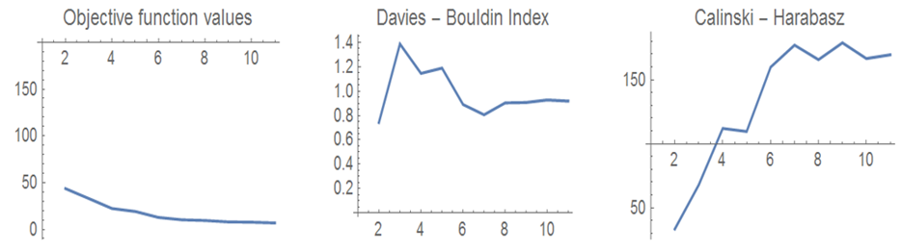

From Figure 3, it is evident that CH and DB indexes show that an optimal partition with k = 7 clusters is the most appropriate partition.

Figure 4: Optimal partition with k = 7 clusters

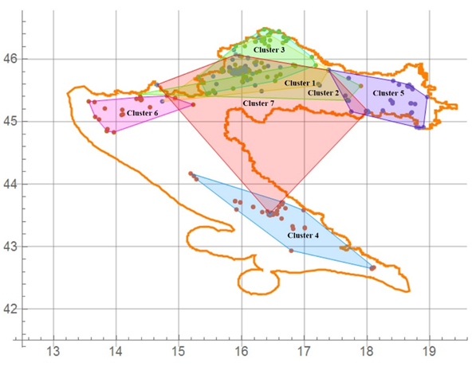

Figure 4 shows that the resulting geographical clusters intersect. This occurs because the algorithm groups the enterprises also by the observed properties (the number of employees, average net salary and value added), and this does not have geographical priority.

After the enterprises are clustered into seven clusters we have selected those five variables which formed clusters as independent variables with purpose to see their effect on capital structure. Dependent variables are capital structure measures. In the Table 1, there are names, description and descriptive statistics of the variables used in the research.

Table 1: Descriptive statistics

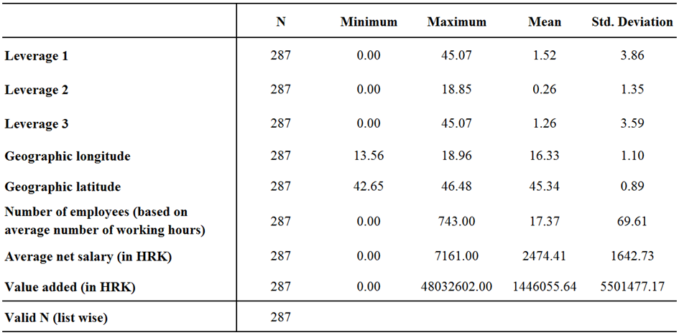
Source: calculation of the authors

Descriptive statistics includes the mean, standard deviation, minimum and maximum values for the year 2015. The data contain 287 enterprises. From Table 1 it can be seen that the mean leverage L1 (total liabilities/total assets) of the analysed Croatian enterprises is respectively 1,5217 indicating that enterprises from the furniture industry cluster are extremely highly levered. Also the ratio of short-term liabilities in total assets (L3) of the enterprises is respectively 1,2587, indicating a highly proportion of short-term debt in total liabilities of enterprises from the furniture industry cluster. The ratio of long-term liabilities in total liabilities of the enterprises was around 26%, indicating that enterprises from the furniture industry cluster are not extremely long term indebted. These results can be caused by reduction in lending to enterprise sector after the economic crisis or insufficient access to finance as a key factor for the development of an enterprises. In this regard, enterprises from the furniture industry cluster are operating with short-term debt.
A correlation analysis for each of seven clusters was performed to verify possible association between and among the variables, in order to test weather is any linear correlation between and among the variables. Table 2 and Table 3 show that only in cluster 2 and cluster 6 there are significant correlations between dependent and independent variables.

Table 2: Correlation matrix in Cluster 2

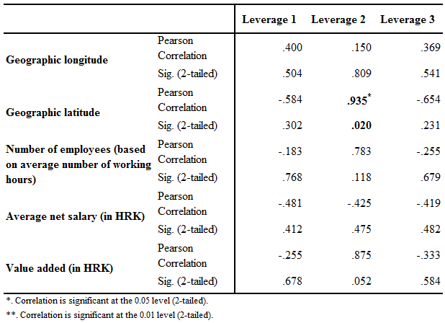
Source: calculation of the authors

Table 3: Correlation matrix in Cluster 6
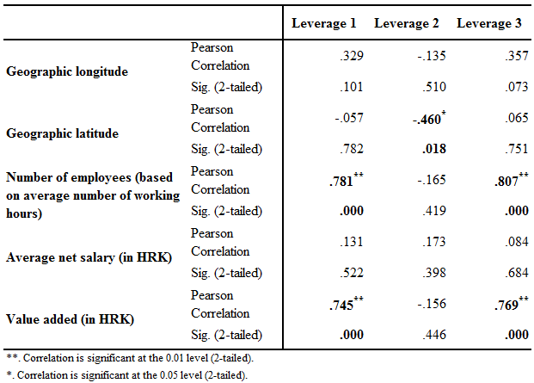

Source: calculation of the authors

- Empirical results
In order to test hypotheses that there are positive relationship between variables which formed clustered enterprises and capital structure measures, we preform regression analysis. In the first part of our analysis, we analysed cluster 2. Each determinant is individually tested in a way that bivariate regression analysis is done with dependent variable L2 (long-term liabilities/total assets) and independent variable geographic latitude. After that, regression analysis is developed with the cluster 6.
Table 4: Results of regression analysis - Cluster 2
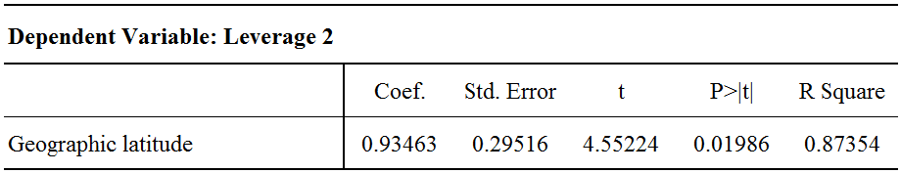
Source: calculation of the authors
In Table 4, estimated regression coefficient is 0.93463 with p-value <0.05 showing that the relationship between long-term leverage and geographic latitude is positive and statistically significant. This is verified also by t-statistics. According to R-square, 87,35 percent of the variation in long-term leverage can be captured by independent variable geographic latitude. Results show that with the increase of geographic latitude, there is an increase in L2 (long term leverage).
Table 5: Results of regression analysis - Cluster 6
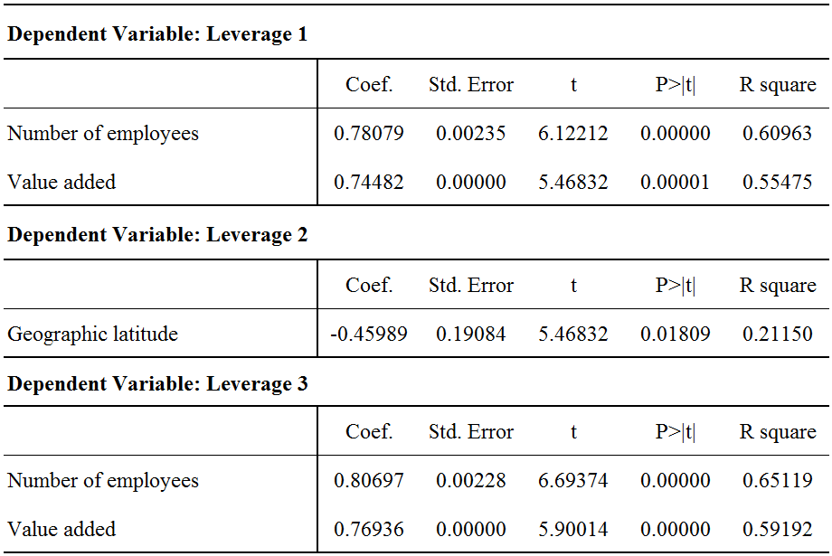

In Table 5, results show that in cluster 6, number of employees and value added positive influence leverage measured by ratio of total liabilities to total assets. The same is shown and with the short-term leverage. It can be noticed that long-term leverage will increase with decrease of geographic latitude, although we expected positive relationship, contrary to cluster 2, where this relationship is positive.

- Discussion of results
The aim of this paper was not to analyse the fundamental determinants of the capital structure, but to analyse the capital structure of enterprises in the furniture industry cluster in Croatia through the analysis of the variables which formed clustered enterprises and capital structure measures. First, it is evident that enterprises in furniture cluster are extremely short-term levered indicating that increase of value added and number of employees induces increase of short term leverage. The results are particularly significant in Cluster 6, where among other clusters, only small and two medium sized enterprises are operating. In Cluster 6 there are 65.4% of enterprises with up to 5 employees, 26.8% enterprises whose number of employees is between 5 and 25, 1 enterprise with 114 employees, and 1 enterprise with 180 employees. According to characteristics from Cluster 2, which has only 5 enterprises, but almost 50% of all employees (47.09%) is employed in these five enterprises, and are no enterprises without employees in this cluster, only the increase of geographic latitude will induce the increase in long term leverage. Regarding these results we can conclude that capital structure can be analysed and through determinants which formed clusters. Regarding our hypotheses there are positive relationship between variables which formed clustered enterprises and capital structure measures, finally we can acknowledge that due to observed variables in furniture industry cluster, number of employees, value added and geographic latitude effect capital structure.

References
Briš, Alić, M., Alić, A., Milković, A. (2017). Clustering in Croatian furniture industry. Croatian Operational Research Review. In progress.
CEPS, CSIL, (2014). The EU furniture market situation and a possible furniture products initiative, available at https://www.ceps.eu/system/files/Final%20report_en.pdf
Communication from the Commission to the European parliament, the council, the European economic and social committee and the committee of the regions, A Stronger European Industry for Growth and Economic Recovery Industrial Policy Communication Update Brussels: European Union. COM(2012) 582 final
Degryse, H.,Goeij, P., Kappert, P., (2010). The impact of firm and industry characteristics on small firms capital structure, Small Bus Econ, Vol. 38, No. 4, pp 431-447
Družić, G.. Basarac Sertić, M. (2015) A roadmap of actions aiming at ensuring furniture industry production growth: panel analysis, Economic Research- Ekonomska Istraživanja, 28:1, 572-582, DOI: 10.1080/1331677X.2015.1083458
European Commission. (2010). Europe 2020. A strategy for smart, sustainable and inclusive
growth. COM(2010) 2020 final, Brussels.
European Commission. (2012). Communication from the Commission to the European Parliament, the Council, the European economic and social committee and the committee of the regions, A Stronger European Industry for Growth and Economic Recovery Industrial, Policy Communication Update, Brussels, 2012
European Commission. (2014c). For a European industrial renaissance. SWD(2014) 14 final.
European Commission, available at https://ec.europa.eu/growth/smes/cluster_hr
European Cluster Panorama 2016, The European Cluster Observatory, European Commission
European Cluster Trends, Preliminary Report, European Commission, Brussels 2014, p.12
Industrial strategy of the Republic of Croatia 2014-2020. Official Gazette, 126/15.
Scitovski, R., Briš Alić, M. (2016). Grupiranje podataka. Odjel za matematiku, Sveučilište u Osijeku, Osijek.
Scitovski, R., Scitovski, S. (2013). A fast partitioning algorithm and its application to earthquake investigation. Computers & Geosciences 59, 124–131.
Shamsur, A., (2010). Access to capital and capital structure of the firm, CERGE-EI WP No.429, available at http://dx.doi.org/10.2139/ssrn.1721455

Situations in which a region is specialised in a set of related industries relative to peers.
Specialisation, measured by the relative size of regional employment in a given (sectoral or cross-sectoral) cluster category reflected in its location quotient (LQ). This relative measure indicates how much stronger a region is in a cluster category than would be expected given its overall size, compared to the average employment size in the specific cluster category across all regions. A localisation quotient equal to 1 means that the given region is not specialized in the given industry. A localisation quotient equal to 2 means that the given industry is represented by a 100% bigger share of employment in the given region than the industry’s share of employment on the level of all regions. This indicates that the region is specialized in the industry.
A cluster gets 1 star for being in top 20% in Europe along each of the four dimensions: size, specialisation, productivity, and growth. Data are extract from 2013.
www.poslovna.hr

