CD spectroscopy distinguishes structurally related mycotoxins
(Razlikovanje strukturno sličnih mikotoksina metodom CD spektroskopije)
…
Daniela Jakšić Despot,¹ Maja Šegvić Klarić,¹ Ivo Piantanida²
¹University of Zagreb, Faculty of pharmacy and biochemistry, Department of microbiology, Schrottova 39, 10000 Zagreb, Croatia

² Ruđer Bošković Institute, Division of organic chemistry and biochemistry, Laboratory for biomolecular interactions and spectroscopy, Bijenička cesta 54, 10000 Zagreb, Croatia.
...
E-mail: (djaksic@pharma.hr)
…
Mycotoxins are secondary metabolites produced by moulds abundant in the different environments. Among these, aflatoxin B₁ (AFB₁) is considered one of the most toxic and is human cancerogen [1]. Structurally related furofurane derivatives (Fig. 1) sterigmatocystin (STC) and 5-methoxysterigmatocystin (5-MET-STC) are direct biosynthetic precursors in AFB₁ producing Aspergilli, but also the final products of biosynthesis occurring in the different types of moulds [2]. Despite similarities in their chemical structures, their toxic properties differ and thus suggesting the differences in their physicochemical properties in water solutions.
In this study we showed CD spectra of AFB₁, STC and 5-MET-STC in organic and water based solvents for the first time. While the CD signal in organic solvent is of low intensity and quite similar for all of the three compounds (Fig. 2A), STC showed distinctive CD signal of unusually high intensity in water (Fig. 2B). In contrast to its structural analogues we suspect such signal of STC is due to its ability to aggregate in water as was confirmed with other methods we applied that will be presented and discussed. The significance of these results is yet to be explored, but they made the basis of a new approach in the analysis of STC in water based solutions, in addition to understanding its behavior in biological systems.

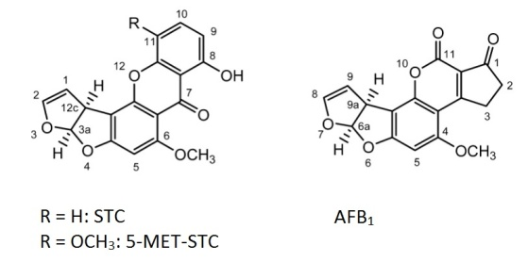 | 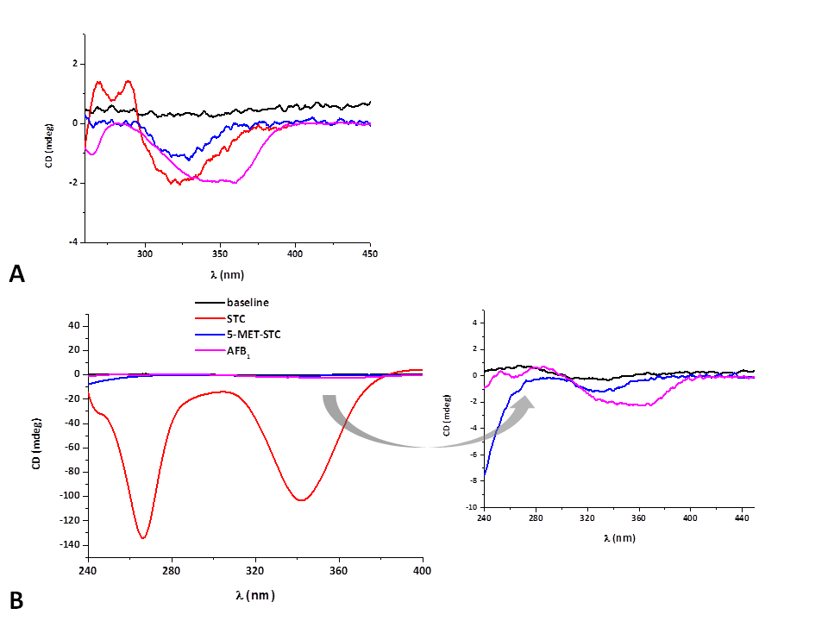
Figure 1: Chemical structures of AFB₁, STC and 5-MET-STC | Figure 2: CD SPECTRA of AFB₁, STC and 5-MET-STC (2x10⁻⁵ M) in acetonitrile (A) and cacodylate buffer (pH=7, I= 0,05 M) (B)

References
[1] IARC, Aflatoxins, in: A review of human carcinogens: biological agents, IARC Monographs Evaluation of carcinog risk to humans 100B (2012) 225–248.
[2] C. Rank, K.F. Nielsen, T.O. Larsen, J. Varga, R.A. Samson, J.C. Frisvad, Fungal Biol 115 (2011) 406–420.

