Concept of Restoration and Preservation of River Odra’s Biodiversity and Eco-system Services (BIO -ODRA)
Duška Kunštek, Ph.D. C.E., Assistant professor,
(Water Research Department, Faculty of civil engineering, University of Zagreb, Kačićeva 26, 10000 Zagreb, Croatia, phone: 00 385 98 359468, fax: 00 385 1 4639 238, e-mail: kduska@grad.h)
Abstract
The river Odra has been heavily modified as a result of flood protection measures, its use as a watercourse for a water treatment plant and by an increased riverside population. Odra as urban source account for significant quantities of important diffuse pollutants, and is typically badly polluted with toxic metals, hydrocarbons including PAHs, and suspended matter, faecal pathogens and nutrients. The Restoration Odra concept (BIO - ODRA) engages 79 120.76 ha of Odra River Basin and it‘s the first environmental assessment of the river towards the European and international river restoration principles. Concrete restoration actions will be taken on upper reach of river Odra, i.e. from its source to the Sava-Odra Channel including Odra’s tributaries (streams Želin, Siget, Kosnica, Ribnica, Lomnica), but project engages bigger area because of the referent monitoring stations on lower reach of river Odra. Hydro-morphological, habitat and physicochemical data collection and monitoring will be done with permits by private landowners and “Hrvatske Vode”. Concrete actions which are planned will be on the State property.
The objective is to establish self-sustaining stream functions and return an ecosystem to a former natural condition. This project also aims to help create a community that is more connected to the environment, with a real appreciation of the critical role of water systems and biodiversity in their lives and lifestyles. In Croatia, we need the community to be completely up to speed and mirroring the WFD overall directions through imaginative, comprehensive and persistent education and awareness programs, and through involvement of community at every step of the way.
Keywords:
River Odra, river restoration, environment, measure, monitoring

Introduction
BIO – ODRA project area engages 79 120.76 ha of Odra River Basin. The long term vision for the river Odra is to have fully wild river and to secure their health and productivity for all time. The aim is to ensure a variety of river dynamics, natural habitats and species while also producing greater benefits in natural goods and services for local people. This should be achieved through the establishment of ecological management of the riverine area as well as the restoration of degraded river and floodplain areas.
The objective is to establish self-sustaining stream functions and return an ecosystem to a former natural condition. The goal is to secure a future for the river Odra and its wetlands as a healthy, productive and resilient wetland system.
Concrete restoration actions will be taken on upper reach of river Odra, i.e. from its source to the Sava-Odra Channel including Odra’s tributaries (streams Želin, Siget, Kosnica, Ribnica, Lomnica), but project engages area bigger area because of the referent monitoring stations on lower reach of river Odra. They will improve conditions for flora and fauna, and ensure high water quality in the river and surroundings system. Proper applying of vegetation for sustainable river management requires: precise calculation of water movement parameters; an understanding of channel hydraulics; and knowledge about biomass distribution and ecology of dominant plant species.
This project involves mapping and assessment ecosystems and theirs services in vicinity of river Odra. Although, EU guidelines about mapping and assessment of ecosystem and their services exist, in Croatia is lack applying them. Also, river restoration is not a novelty in EU and it is at the forefront of applied hydrologic science, but in Croatia there is no example of restored river and associated floodplains implementing ecological and biological engineering. While many projects, supported through EU programmes, have already successfully finished or are still in progress, in Croatia, river revitalization and restoration is an innovative approach of river management.
Hydro-morphological, habitat and physicochemical data collection and monitoring will be done with permits by private landowners and “Hrvatske Vode”. Concrete actions which are planned will be on the State property.
The hydromorphological monitoring and assessment will be done according to the “Meander - Guideline for Hydromorphological Monitoring and Assessment of Rivers in Croatia” which fully meets the EU Water Framework Directive requirements.
Hrvatske Vode (CV) has ample experience in flood protection, however mostly by technical (structural) measures that often adversely affect the ecological status. Experience is lacking in the assessment and mitigation of adverse effects of hydromorphological modifications and pressures on habitats and biota. To enhance sustainability, Croatia is therefore keen to develop its capacity to monitor and assess hydromorphological features in rivers and to design and implement measures in the River Basin Management Plans (RBMP’s) and Management Plans to improve the ecological status. Integrated river restoration is also seen as a promising tool to reduce hydromorphological pressures, in order to meet the objectives of the WFD, Birds, Habitat and Floods Directives.
So, in fact, dissemination of the project results will be achieved according to recommendations in „Meander - Guideline for River Restoration Plans in Croatia“

General description of the area targeted by BIO – ODRA project
River Odra is flowing through field called „Odransko polje“, parallel to the river Sava and near town Sisak flows into the river Kupa. River Odra and its floodplain ranges from 95 to 110 m altitude. The Odra is connected to the River Sava by the Sava-Odra Relief Channel (built in 1965), which serves to deliver excessive water from the Sava to prevent it from flooding upstream urban areas (especially Zagreb) and it provides transportation of burdened waters from river Sava to retention area of the Odransko polje. Sava-Odra Relief canal artificially divided the Odra River in two parts; 6 km of strongly anthropogenically affected upper reach (river source area) and more preserved middle and lower reach. The catchment area of the Odra covers 604 km² and total length of the course is about 80 km. Due to the low slope (0.13%) the river meanders significantly. Water level of Odra is closely related to the water level of the Sava River. The largest part of its water volume is groundwater of the Sava River. Odra is the left tributary of the Kupa River and during high flows of the Sava and Kupa rivers, the Odra basin provides a retention area of about 30,000 ha along 30 km of its course. During dry periods, the Odra-Sava canal drains the basin to some extent. Thus, since 1965 the water table has dropped by 60 to 90 cm, with negative consequences for hydrology of streams in headwater area and for the ash and partly for the oak forests. Average riverbed width is about 25 - 30 m, and the maximal depth reaches 4 - 5 m.
Odra floodplain is important area for birds, among which corncrake (Crex crex) and white-tail eagle (Haliaeetus albicilla) are indicators of good condition of flooded meadows and forests along the Odra River. The vegetation composition and structure is strongly determined by the flood dynamics and groundwater level correlating the lowland topography.
For the purpose of this concept, we have divided the river Odra in two main sections (Fig. 1.):
UPPER REACH is river section from its source downstream to the crossing of river and channel Sava-Odra. At this crossing is one of the main issues/problems: malfunctioning siphon. This object was intended to lead river Odra's flow beneath the channel Sava-Odra, but it was never finished.
MIDDLE and LOWER reach is the section of the river Odra from siphon downstream to the river mouth (into river Kupa).
Main issues addressed within this concept of the project are concentrated in the upper reach of the River Odra, with lesser negative effects in the middle and lower reach. Upper reach of the river is situated in the area with significant proportion of agricultural land. Floodplain along the middle and lower reach is dominated by lowland floodplain forests, especially along the right bank of the river.
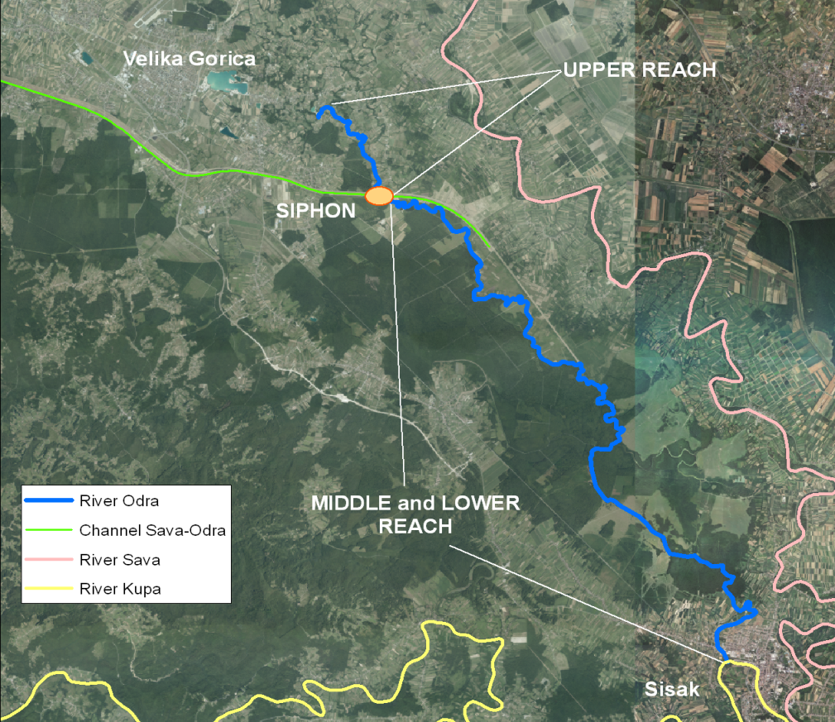
Fig. 1. River Odra divided in two main sections: Upper and Lower Reach

Basic impacts
In the last few decades in the Odra catchment, but also in the wider area, there was a significantly increased urbanization and settlements expansion, which represents one of the greatest pressures on the environment. At the same time, there have been significant changes in the groundwater regime in the area of the Sava alluvium, or their reduction due to increased exploitation of drinking water and lowering the water level of small and medium-sized water of river Sava. River Odra has no classical source, but is formed from groundwater, these changes have led to a reduction of flow in the river and its tributaries (Figure 2.).
It is also a major problem of the river Odra sewage and industrial wastewater, especially from nearby farms, businesses and households, whose drainage systems have not yet been adequately solved. It was also determined the deterioration of water and it is now in a lower category, primarily by the amount of organic compounds. Odra and channel Sava-Odra are moderately polluted water and belong to the second degree of solvency.
Potentially large source of pollution of surface and groundwater is nitrate leaching from manure, settlements and agricultural fields. In the lower reach, there is also a Waste water treatment plant from Sisak, which also releases the treated water into the river Odra.
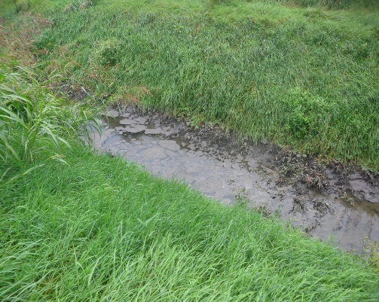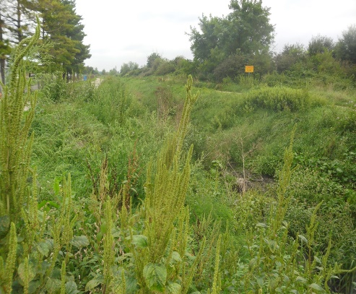
Fig. 2. Drought in stream Želin during dry period (left) and pollution from wastewater treatment plant in Velika Gorica by discharge of treated and untreated wastewater (right)
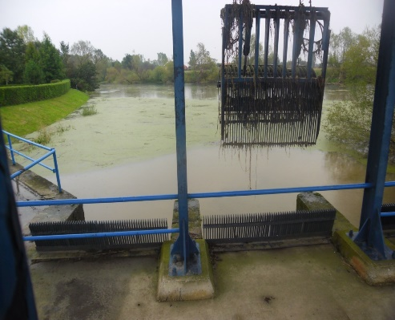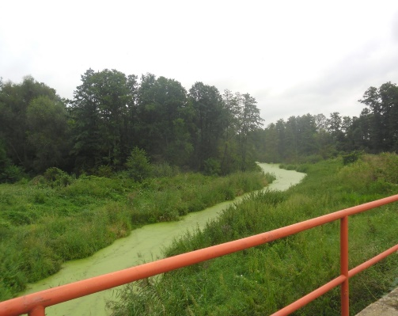
Fig. 3. Eutrophication and sedimentation caused by the “Syphon” (left) and Eutrophication impact in Stream Želin (right)
At the start of the flow of Kosnica and Ribnica, the bed is filled just in the rainy season, and during high groundwater level and water level of the river Sava. However, due to the continued trend of lowering of groundwater levels, these streams especially Kosnica, are drying up on the upstream side of its course. Very small slope and congestion of stream Želin caused water stagnation and eutrophication (Figure 3.). Due to the drought at the middle of the channel, it is assumed that the water in the end of channel and in stream Želin is backwater of river Odra.
One of the most negative impact on biodiversity is located in Poljana Čička, i.e. River Odra is interrupted by Sava – Odra Relief channel, where, through the siphon, part of the water of the river Odra engages in channel Sava – Odra (due to unfinished syphon) and part of the water leads through amelioration channel GA2, which is parallel with channel Sava – Odra. After approximately 12km from the siphon, amelioration channel GA2, again, flows into the Odra River. The siphon causes slowing the flow which causes sedimentation and eutrophication.

Analysis of groundwater regime in Velika Gorica and Odransko Polje
The thickness of the aquifer is on average 40 m a. s. l. on the South and according to existing knowledge, it can range up to a 100 m a. s. l. in the North, but thickness distribution is spatially poorly known. Location of piezometers and previous studies are mainly related to the water supply. Water level analyses with piezometers were made for the time period from 1988 to 2005. Groundwater quality assessment and classification based on the allowable limit values of certain groups of indicators that characterize the sources and causes of water pollution is given in (Tab. 1.) for year 2004.
Tab 1. Classification of groundwater – Velika Gorica area (Glasnik Zagrebačke županije; ISSN 1845-8602; Broj 21; Godina XI., Zagreb, 4. listopada 2006.)
VELIKA GORICA - classification of groundwater for year 2004. |  |  | 53016-VG-9
Groups of indicators | Indicator | Unit of Measure | n | Relevant value | type | Rating
A -physical and chemical | pH value |  | 2 | 7.225 | I
 | electro conductivity | µS/cm | 2 | 675 | II
B- oxygen balance | KPK - Mn | mgO₂/l | 2 | 0.35 | I | I
C -nutrients | ammonium | mgN/l | 2 | 0 | I | I
 | nitrites | mgN/l | 2 | 0 | I
D - Microbiological | Number of kolif. bacteria | UK in 100mL | 2 | 18 | I | I
 | Number of faecal bacteria | in 100mL | 1 | 0 | I
 | Aero bacteria number 37 °C | in 1mL | 2 | 22 | I
F- total metals | copper | µg/l | 2 | 1 | I
 | zinc | µg/l | 2 | 0.5 | I
 | cadmium | µg/l | 2 | 0 | I
 | chrome | µg/l | 2 | 0.5 | I
 | nickel | µg/l | 2 | 0.5 | I
 | lead | µg/l | 2 | 0.5 | I I
 | Hydrargyrum (Hg) | µg/l | 2 | 0 | I
G - organic compounds | mineral oil | µg/l | 2 | 4.45 | I
 | phenols | mg/l | 2 | 0 | I
 | lindane | µg/l | 2 | 0 | I
 | ppDDT | µg/l | 2 | 0 | I

Conservation / biodiversity problems and threats
The upper reach of Odra River is anthropologically highly impacted river stretch. It is exposed to water pollution due to combination of the occurrence of untreated (from 1974 -1988) and poorly treated wastewater from the town of Velika Gorica, farming, butchery and meat industry (and other point pollution sources), illegal waste water load from private houses and pollution load from intensive agriculture. Substrates for benthic communities have been markedly changed due to deposition of fine mud and sludge. According to recent stady [Filipović et al, 2013] the sludge from wastewater treatment plant in Velika Gorica is being considered as a hazardous waste and a subject of discussion regarding disposal due to high total metal concentration in sludge samples. There is no metal concentration analysis in riverbed of stream Želin and upper Odra River reach, but probaly could be real treat due to food web heavy metal accumulation. In the upper reach aquatic communities are markedly changed, i.e. limnephilic organisms prevail instead of rheophilic ones. This trend has been observed in various organisms, e.g. in macrophytes, macroinvertebrates and fish [Duplić et al., 2011], [Mihaljević et al., 2011], [Mihaljević unpublished data]. Thus, according to available data, the middle reach of the Odra River could be considered as a reference site.

Proposed restoration techniques
River restoration techniques involve using only raw natural materials as river bed stabilization or improving river bed morphology for spawning, covering river bed with specific and native plant species as water regime stabilization. By smart applying of the river restoration techniques, we can help to river Odra ecosystem to regenerate itself and to help the nature to get into a balance again by improving biological diversity. Proposed restoration techniques on BIO – ODRA are given in Tab. 2.

Conclusion
The best way to restore the river environment of BIO – ODRA is not to reengineer it, but for the river to restore itself through natural processes: ‘self healing’ is best done by removing or reducing human interventions. One important issue is to restore connectivity within the hydrologic system as a base for a recovery of the biological function. New initiative for managing and restoring BIO - ODRA is interdisciplinary, integrative, and need to plan for different spatial and temporal scales and to develop sustainable flood risk management as part of an integrated and holistic approach to river Odra basin management. For the long-term sustainability of the project’s results, especially with regard to birdlife, it is essential that the wetland and meadow area are grazed.
This project aims to help create a community that is more connected to the environment, with a real appreciation of the critical role of water systems and biodiversity in their lives and lifestyles. In Croatia, we need the community to be completely up to speed and mirroring the WFD overall directions through imaginative, comprehensive and persistent education and awareness programs, and through involvement of community at every step of the way.

Tab 2. Proposed restoration techniques on BIO – ODRA
Threat/  Problem | Description/Drivers | Location | Impact on biodiversity | Proposed measures
Reduced stream discharge in Odra River | hydrological, drop of the groundwater level in alluvial plain of the Sava River | Odra River Upper reach | - Considerable changes in aquatic community composition and structure:  - Communities characterised by taxa typical for lentic habitats and stagnant waterbodies (limnephilic instead of rheophilic); benthic macroinvertebrates, fish, macrophytes, phytobenthos  - Reduction in overall diversity specific for natural flowing water condition (flora & fauna)  - Changes in population densities and functional feeding guilds of aquatic organisms | Revitalization measures recharge Želin stream (which flows into the Odra River), refers to the Intake structures of water from two lakes that are close by (Lake Novo Čiče and Omladinsko Lake and flow into Želin.  It is important to establish a monitoring water quality at both locations, in order to control the entry pollutants in Želin, and thus the Odra River. If monitoring shows that water quality in lakes is not environmentally acceptable, then the water diversion should be linked to a measure of water purification through the Recipient channel established construction self-purification lagoon, directly behind the discharge from the treatment of Velika Gorica, ca 1 km upstream.  If, however monitoring showed satisfactory water quality, engaging water from the lake would then be applied for 1 km downstream of the treatment plant
Water pollution in Odra River due to | 1) malfunctioning and insufficient capacity waste-water treatment plant in the city of Velika Gorica  2) other sources of pollution (illegal outlets into Odra)  3) agriculture | especially expressed in the Upper reach, but also present downstream in the Middle and Lower reach | - Development of toxic cyanobacteria due to increased level of phosphates and nitrates from waste water treatment plant and agriculture  - Development of nitrophilous and toxin resistant plants  - Considerable changes in aquatic community composition and structure | Revitalization measures of removing contaminants from water streams of developing constructedl wetland (CW). This self-cleaning solution is predicted for: Urban Waste Water (small settlements, individual homes, tourist and organic farms, tourist facilities, • non-point source pollution (urban, agricultural and roadway runoff); Method is based on extensive research of the application of various plant species, sand substrates and water flow modes, enabling efficient removal of pollutants from water through physical and chemical processes, microbial activity and plant uptake
Deposition of fine organic particles in the riverbed | Hydrological (river impoundment) and organic pollution (waste-water treatment plant) | upper reach | - Anoxia appearance, development of anaerobic bacteria in sludge;- toxic metal accumulation in the riverbad;- Considerable changes in aquatic communities due to changes in substrate composition | Silt / sludge removal measure a consequence of the discharge of untreated water from treatment plants in Velika Gorica
River fragmentation due to malfunctioning siphon | hydrological, uncompleted siphon | point between Upper and Middle reach | - Population fragmentation and alteration of migration patterns of aquatic species (fish, aquatic macroinvertebrates, aquatic mammals, etc.)  - Lower genetic diversity in local populations and appearance of genetic drift | Revitalization measures reconnection of the Upper and Middle reach of the river Oder, which would flow upstream part of the River Odra has increased significantly. Solution reconnection riverbed implies microtunelling below flood control channel Sava - Odra of ameliorative channel GA2 by the middle reach of the Odra.

References
GLASNIK ZAGREBAČKE ŽUPANIJE; ISSN 1845-8602; Broj 21; Godina XI., Zagreb, 4. listopada 2006.
FILIPOVIĆ, J., GRČIĆ, I., BERMANEC, V., KNIEWALD, G. Monitoring of total metal concentration in sludge samples: Case study for the mechanical-biological wastewater treatment plant in Velika Gorica, Croatia, Science of the Total Environment 447 (2013), 17-24;
BAČANI, A., POSAVEC, K., PARLOV, J. 2010. Groundwater quantity in the Zagreb aquifer.-In: ZUBER, A., KANIA, J. & KMIECIK, E. (eds.): XXXVIII IAH Congress Groundwater Quality Sustainability, Krakow, September 12–17, 2010, 87-92.
BARTOLEC, M. 2012. Izvješće o provedenom istraživanju (monitoringu) štekavca (Haliaeetus albicilla) na području Sisačko-moslovačke županije. Izvješće za Državni zavod za zaštitu prirode, Zagreb.
BARTOLIĆ, G. 2005. Aktivnost šišmiša u različitim tipovima staništa u šumi Turopoljski lug. Magistarski rad. Biološki odsjek, Prirodoslovno-matematički fakultet Sveučilišta u Zagrebu.
DRVODELIĆ, D. 1999. Ekološki prostorni značaj Turopoljskog luga. Diplomski rad. Šumarski fakultet Zagreb.
DRŽAVNI ZAVOD ZA ZAŠTITU PRIRODE 2011. Provođenje edukacije i osposobljavanje za provođenje Akcijskog plana za očuvanje ptice kosac (Crex crex) u Odranskom polju u Zagrebačkoj županiji. Završno izvješće za Javnu ustanovu za upravljanje zaštićenim područjima i drugim zaštićenim prirodnim vrijednostima Zagrebačke županije.
DRŽAVNI ZAVOD ZA ZAŠTITU PRIRODE, 2005. Značajni krajobraz Odransko polje. Stručna podloga za zaštitu.
DUMBOVIĆ, V. 2008. Praćenje brojnosti kosaca (Crex crex) na području Odranskog polja i Sunjske Grede (Gredskim sinokošama). Izvješće za 2008. Godinu. Izvješće za Javnu ustanovu za upravljanje zaštićenim prirodnim vrijednostima Sisačko-moslavačke županije.
DUPLIĆ, A., BORŠIĆ, I., KATUŠIĆ, L. 2011. Ocjena stanja biološke raznolikosti rijeke Odre i prijedlog mjera za poboljšanje stanja očuvanosti područja ekološke mreže ''Odra HR 2000631''. Studija, DZZP, Zagreb.
EKOLOŠKA UDRUGA EMYS 2009. Istraživanje rasprostranjenosti vidre (Lutra lutra L.) na području kontinentalne Hrvatske. Državni zavod za zaštitu prirode.
Filipović et al, 2013
GRBAC, I. 2009. Znanstvena analiza vrsta vodozemaca i gmazova (Eurotestudo hermanii, Emys orbicularis, Bombina bombina i Bombina variegata) s dodatka II Direktive o zaštiti prirodnih staništa i divlje flore i faune. Hrvatski prirodoslovni muzej, Zagreb.
GRUBEŠIĆ, M. 2008. Dabar u Hrvatskoj. Šumarski fakultet sveučilišta u Zagrebu.
GRUBEŠIĆ, M., TOMLJANOVIĆ, K., KOVAČ, I. 2008. Znanstvena analiza dabra (Castor fiber L.) na području Hrvatske. Državni zavod za zaštitu prirode.
IVKOVIĆ, M. & HORVAT, B. 2007. Hemerodromia raptoria (Meigen) a newly recorded species of aquatic dance flies (Diptera, Empididae) in Croatia and its distribution on Balkan Peninsula. Natura Croatica, 16, 79–82.
JAVNA USTANOVA ZA UPRAVLJANJE ZAŠTIĆENIM PRIRODNIM VRIJEDNOSTIMA SISAČKO-MOSLAVAČKE ŽUPANIJE 2011. Rezultati prebrojavanja kosaca (Crex crex) za 2010, 2011. I 2012. Interni dokument.
MIHALJEVIĆ, Z. ET AL. 2011. Testiranje bioloških metoda ocjene ekološkog stanja (Okvirna direktiva o vodama, 2000/60/EC) u reprezentativnim slivovima Panonske i Dinaridske ekoregije, Studija, Prirodoslovno-matematički fakultet Sveučilišta u Zagrebu, Biološki odsjek, Zagreb.

