Discovery of the oldest fossils of Panama: Early Cretaceous radiolarians from Miocene conglomerate in the Canal Zone
KUKOC, Duje ¹⁾, BUCHS, David M. ²⁾, BAUMGARTNER, Peter O. ¹⁾, MIRANDA, Roberto ³⁾, IRVING, Derek ³⁾
1) Institute of Earth Sciences, University of Lausanne, Géopolis, CH-1015 Lausanne, Switzerland. Duje.Kukoc@unil.ch, Peter.Baumgartner@unil.ch
2) School of Earth and Ocean Sciences, Cardiff University, UK. BuchsD@cf.ac.uk
3) Panama Canal Authority, Panama. DIrving@pancanal.com

Here we present the first report of Panama's, so far, oldest fossils: Early Cretaceous (late Hauterivian - Barremian) radiolarians recovered by HF- treatment form chert granules-pebbles collected by D.B. and R.M. in a Miocene fluvial conglomerate recently excavated for the enlargement of the Panama Canal (Fig. 1).
Panama's oldest fossils were previously reported from radiolarites interbedded with oceanic plateau lavas in the Azuero Complex, W Panama (Kolarsky et al. 1995, references in Buchs et al. 2010). They revealed a Coniacian-Santonian radiolarian assemblage very similar to that recovered in oceanic plateau sequences from the youngest part of the Nicoya Complex, N Costa Rica (Bandini et al. 2008, Baumgartner et al. 2008). These radiolarian assemblages are also possibly similar to that reported in E Panama (Bandy & Casey 1973), where preliminary results from on-going regional work (GRIP, https://panamageology.wordpress.com/) also suggest their association with plateau lavas. Most of the Upper Cretaceous oceanic plateau sequences in the region are likely part of the Caribbean Large Igneous Province (CLIP) that extends over most of the Caribbean Plate (Fig. 1 inset). Other Cretaceous fossils in Panama include foraminifers in upper Campanian pelagic limestones that locally unconformably overlie Coniacian-Santonian oceanic plateau sequences, and are thought to represent a regional stratigraphic marker associated with the initiation of the Panama volcanic arc on top of the SW margin of the CLIP (Buchs et al. 2010, Barat et al. 2014).
The finding of Early Cretaceous radiolarians in chert clasts reworked into a Miocene conglomerate in the Canal Zone is a significant result that reveals existence of an older (pre-CLIP) oceanic basement in the Panama Isthmus. The clasts yielded poorly preserved but diverse radiolarians. Co-occurrences of Pantanellium sp. aff P. cantuchapai Pessagno & MacLeod sensu Baumgartner et al. 1995 and Stylospongia (?) titirez Jud give the shortest age assignment from late Hauterivian to early Barremian (UAZ95 20-21). Squinabollum simplex (Taketani) also has its first appearance in UAZ95 20, however, this assignment is tentative in view of corroded specimens. A somewhat broader age can be assigned by the first occurrence of Cyclastrum planum Jud in early Hauterivian (UAZ95 19) and disappearance of representatives of Spinosicapsa in early Aptian.
In Central America such assemblages are only known from Middle Jurassic to Lower Cretaceous radiolarites in the Santa Rosa Accretionary Complex, N Costa Rica (Bandini et al. 2011), and those magmatically reworked in the Nicoya Complex (Denyer & Baumgartner 2006). These occurrences, including the one reported here, suggest that Early Cretaceous and older, far-travelled plateau fragments out of Panthalassa, accreted along, or form the basement of, the CLIP. Provenance constraints from the Canal conglomerate favors occurrence of an older plateau at the base of the CLIP and the Panama Isthmus, which remains to be found in situ in central Panama.

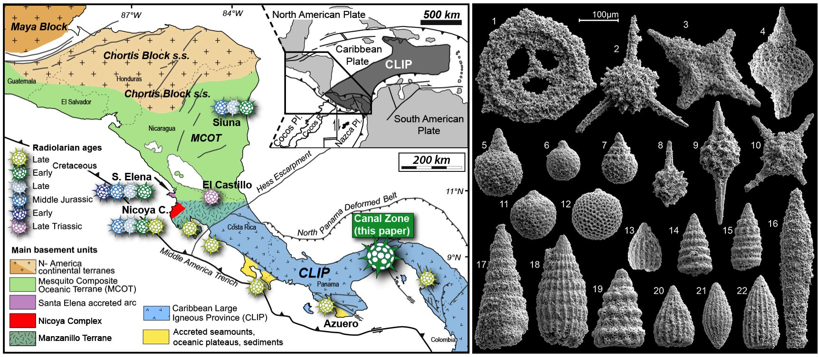
Figure 1. Late Hauterrivian – Barremian radiolarians from the Panama Canal Zone. 1) Cyclastrum planum (Jud), 2) Becus helenae (Schaaf), 3) Crucella cachensis Pessagno, 4) Spinosicapsa typica (Rüst), 5) Squinabollum sp. cf. S. simplex (Taketani), 6) Gongylothorax sp., 7) Hiscocapsa uterculus (Parona), 8) Pantanellium sp. aff. P. cantuchapai Pessagno & MacLeod, 9) P. squinaboli (Tan), 10) Stylospongia (?) titirez Jud, 11) Cryptamphorella conara (Foreman), 12) Cryptamphorella sp., 13) Thanarla brouweri (Tan), 14) Svinitzium puga (Schaaf), 15) Pseudodictyomitra lilyae (Tan), 16) Pseudoeucyrtis sp., 17) Crolanium sp. cf. C. cuneatum (Smirnova & Aliev), 18) Dictyomitra pseudoscalaris (Tan) sensu Schaaf, 19) Xitus clava (Parona), 20) Thanarla conica (Aliev), 21) Archaeodictyomitra lacrimula (Foreman), 22) A. vulgaris (Pessagno)
References
Bandini, A.N., Baumgartner, P. O., Flores, K. & Dumitrica, P. 2011. Early Jurassic to Early Late Cretaceous radiolarians from the Santa Rosa accretionary complex (northwestern Costa Rica). Ofioliti 36, 1-35.
Bandini, A. N., Flores, K., Baumgartner, P. O., Jackett, S.-J. & Denyer, P. 2008. Late Cretaceous and Paleogene Radiolaria from the Nicoya Peninsula, Costa Rica: a tectonostratigraphic application. Stratigraphy 5, 3-21.
Bandy, O.L. & Casey, R.E. 1973. Reflector Horizons and Paleobathymetric History, Eastern Panama. Geological Society of America Bulletin 84, 3081-3086.
Barat, F., Mercier de Lépinay, B., Sosson, M., Müller C., Baumgartner, P. O. & Baumgartner-Mora, C. 2014. Transition from the Farallon Plate subduction to the collision between South and Central America: Geological evolution of the Panama Isthmus. Tectonophysics 622: 145-167.
Baumgartner, P. O., Flores, K., Bandini A. N., Girault, F. & Cruz, D. 2008. Upper Triassic to Cretaceous radiolaria from Nicaragua and northern Costa Rica – The Mesquito composite oceanic terrane. Ofioliti 33, 1-19.
Buchs, D.M., Arculus, R.J., Baumgartner, P.O., Baumgartner-Mora, C. & Ulianov, A., 2010. Late Cretaceous arc development on the SW margin of the Caribbean Plate: Insights from the Golfito, Costa Rica, and Azuero, Panama, complexes. Geochemistry Geophysics Geosystems 11, Q07S24.
Denyer, P. & Baumgartner, P. O. 2006. Emplacement of Jurassic-Lower Cretaceous radiolarites of the Nicoya Complex (Costa Rica). Geologica Acta 4, 203-218.

Keywords: Lower Cretaceous radiolarite, Miocene, Panama Canal, Panama Isthmus

