Temperature as an important factor in rotary welding of wood

Žulj, Ivan^{1*}; Župčić, Ivica¹; Grbac, Ivica¹; Slivar, Valentino¹ Radmanović, Kristijan²
¹Department for Furniture and Wood Products, Faculty of Forestry, University of Zagreb, Zagreb, Croatia
²Department of Processes Engineering, Faculty of Forestry, University of Zagreb, Zagreb, Croatia
*Corresponding author: izulj@sumfak.hr

ABSTRACT

Welding of wood is an innovative way of connecting wood, or pieces of wood, without the use of glue or other binder. The main reason of welding are melting of the welding surface layers of wood (lignin and hemicelluloses) and physical and chemical reactions that lead to the solidification of the melt and creating a solid compound.
The paper will investigate the influence of the rotation frequency (1520 min⁻¹) and the welding depth (20 mm) on the temperature in the rotary welded joint. The welding direction is perpendicular to the direction of the fibres with constant welding time. The temperature is measured by means of measuring probes set vertically on the welding direction. The position of the measuring probes is defined in this study. The probe closest to the surface (probe 1) achieves an average temperature of 184 ° C. Probe 4, which is 16 mm away from the surface, achieves at least the average temperature of 68 ° C. The average embedded force is 1631 N. The welding of pine wood is shown in a three-dimensional rectangular coordinate system.

Key words: welding solid wood, dowels, welding temperature, weld factors, embedded force

- INTRODUCTION

Welding of wood is a relatively new way of bonding two or more wood elements or wood boards without the use of adhesive. The welding process causes thermally-induced softening of wood components (lignin and hemicelluloses) leading to polymerisation, while the surface wood layers melt when in contact (due to the friction between two pieces of material). The result is the destruction of the cell wall in the interfacial zone and a considerable increase in the density in the welding zone. Mechanical friction (which produces high temperatures), pressure fore and chemical reactions at the cooling stage make cell walls burst. The joints produced in this way can be compared to other ways of bonding. Much recent research has been dedicated to wood to find new ways of the application of this valuable and renewable raw material.
Kanazawa et al. (2005) studied parameters that affect a dowel during rotational welding. Two types of dowels were used for the study – a smooth and a grooved dowel (Type A and Type B), with a diameter of 10 mm and a length of 80 mm. The depth of the receiving holes drilled in the beech samples was 30 mm with the first 20 mm having a diameter of 8 mm, and the remaining 10 mm a diameter of 7.5 mm. Welding frequency was set at 1200 min⁻¹. After the welding, the samples were conditioned (at 20°C and 65% air humidity) over a week. The welding rate varied, 100 mm/min and 400 mm/min. A temperature slightly above 183°C was generated during the welding process. However, the temperature went down rapidly – it took just a minute to go down to 60 – 70 °C. A thermal camera was used to measure temperature. In order to allow recording, a slot was made on the receiver hole through which the thermal camera could directly measure the temperature. The authors concluded that the temperature was likely to exceed 200°C. However, the restricted speed of the camera prevented them from measuring the accurate temperature. This was confirmed by subsequent studies by Rodriguez et al. (2010). Rodrieguez et al. carried out a study using birch wood (Betula Alleghaniensis) and maple wood (Acer Saccharum). For the study, they used smooth beech dowels of 9.68 mm in diameter and 82 mm in length. Receiver holes of various dimeters (7.14, 7.37 and 7.67 mm) were drilled into the birch and maple samples in three different directions (radial, tangential and longitudinal direction) to a depth of 25 mm. Three rotation frequencies were used (1000, 1500 and 2500 min⁻¹). Prior to welding, the samples had been conditioned (at 20°C and 65% air humidity). In order to measure the temperature, rapid response sensors were inserted in the lateral receiver holes at a distance of 1 and 2 mm from the bond line. Welding temperature is directly correlated with the rotation frequency. That is, the higher the rotational frequency, the higher the temperature.
Leban et al. (2008) conducted a study into the impact of frequency on rotational welding. They used grooved beech dowels (Fagus Sylvatica) of 12 mm in diameter and 80 mm in length. Samples used were made of spruce wood (Picea Abies) with a moisture content of 12%. Receiver holes had a diameter of 9.5 mm to a depth of 15mm, and 8 mm to a depth of 46 mm. Embedded strength was examined on the samples that were welded at the frequency of 1500, 4000, 6000 and 6500 min⁻¹. Welding time was between 2 and 4 s. The best results in embedded strength were obtained at a frequency of 1500 min⁻¹, whereas an increase in frequency resulted in lower strength. Higher welding frequencies produced a higher concentration of destroyed tissue i.e. a high increase in temperature was generated, so that melted material shifted further away from the bond line and created thus a gap.
Research into rotational welding was also conducted at the Faculty of Forestry of the University of Zagreb. Župčić et al. (2008) examined the optimal shape of the receiver hole where the bond line would run along the entire periphery of the dowel. A study was done in the welding-through doweling of oak and spruce samples with the oak substrate always placed on the upper side. The specimen dimensions were 30 x 200 x 40 mm. The study used receiver holes of different diameters, 9, 8, 7 and 6 mm respectively. 4 specimen types and one glued specimen were used. Type 1 had a receiver hole of 8 mm in diameter along the entire depth of the hole. Type 2 had a receiver hole of 8 mm in diameter in the oak element, and in the spruce element, a hole of 8 mm in diameter to a depth of 10 mm, whereas the hole diameter for the next 10 mm was 6 mm. Type 3 had a receiver hole of 8 mm in diameter through the oak element, and of 6 mm in diameter through the spruce element. Type 4 consisted of four zones of the hole diameter. For the first 15 mm of the oak element, the diameter was 9 mm, and for the next 15 mm, it was 8 mm. For the first 10 mm of the spruce element, the diameter was 7 mm, and for the final 10 mm it was 6 mm. The grooved dowels that were used had a diameter of 10 mm. A comparison was made with the samples with glued dowels. The conclusion suggests that there is a statistically significant difference between the glued and the welded dowel. The dowel glued to the oak substrate yields higher embedded force compared to the dowel welded to the oak substrate. Further, the results show that the dowel welded to the oak substrate yields higher embedded force compared to the dowel glued or welded to the spruce substrate. Type 1 samples produced the lowest embedded strength. No statistically significant difference was found between Type 2 and Type 3 samples. As expected, Type 1 yielded the lowest embedded strength, and Type 4 with its step-decreasing hole diameter yielded the highest results.
Auchet et al. (2010) studied a comparison between a constant welding speed and a changing (increasing) welding speed. For their study, they used 80-mm long grooved and smooth beech dowels of 10 mm in dimeter. The samples were made of beech (Fagus Sylvatica), and the receiver holes had a dimeter of 8 mm and a depth of 24 mm. Welding frequency amounted to 1600 min⁻¹. After the welding process, the samples were put aside for conditioning (at 20°C and 65% air humidity) over a week. The welding machine could be operated during the welding process at various rates. The highest embedded force (4.7 MPa) was generated at a constant welding speed of 20 mm/s, whereas the changing welding speed generated an embedded force of 3 MPa.
Župčić et al. (2014) examined the impact of wood species and cross-sections on the strength of the joint obtained by rotational welding. The samples used were made of beech (Fagus Sylvatica L.), pedunculate oak (Quercus Robur L.) and spruce (Picea Abies L.). Welding direction during the study was parallel to the substrate fibres and perpendicular to their orientation (radial, radial/tangential and tangential). Grooved beech dowels used in the experiment had an average diameter of 10.04 mm, and the samples were drilled with a drilling bit of 8 mm in diameter. The samples were conditioned over a 6-month period at 23+ 2°C and 50 + 5% air humidity. Prior to the testing, the moisture content and the substrate density were measured. The beech substrate had a moisture content of 9.13% and a density of 0.68 g/cm³, and the oak substrate had a moisture content of 9.33% and a density of 0.69 g/cm³. For the spruce substrate the moisture content was 10.37%, and the density was 0.45 g/cm³. The dowels were welded to a depth of 20 mm with a rotation frequency of 1520 min⁻¹. The study results show that the wood species and the cross- section have an important impact on the embedded force. The highest results for the embedded force were yielded by the dowels welded to the beech transverse cross-section. It was also shown that that there is a statistically significant difference between the value of the embedded force for the dowels welded parallel to the fibre orientation and those welded perpendicular to the fibre orientation. However, no statistically significant difference was found between the value of the embedded force in the direction perpendicular to the fibre orientation (radial, radial/tangential and tangential). The study results show that beech is the most suitable wood species for dowel welding regardless of fibre orientation.

2. MATERIALS AND WORKING METHOD
2.1 Samples, welding parameters and moisture content
The study was conducted at the laboratory of the Department for Furniture and Wood Products at the Faculty of Forestry of the University of Zagreb. Pine wood (Pinus Sylvestris L.) for the study had been selected randomly from the stack of sawn dry timber. Criteria for the element selection were as follows: the sawn timber had to be of regular structure, without any knots, cracks and damages. Smooth beech dowels of 1000 mm in length were used during the selection of the material for the study (random selection was employed). To fit with the study purpose, smooth dowels were made by planning on a four- sided planer, and were trimmed to a length of 120 mm. Table 1 displays welding parameters, sample designation and the total number of samples.

Table 1. Sample list and their designations
Sample designation | Wood species | Rotation frequency (min⁻¹) | Welding penetration (mm)
BO_1520_20_x | Pine wood | 1520 | 20
Number of samples: 30 pcs
x- stands for the ordinal number of the welded dowel (1-30)

The pine samples were conditioned at a temperature of 23 + 2°C and a relative air humidity of 50 + 5%. All samples had more or less the same radial-tangential texture (Figure 1). Sample dimensions and their weight were measured in order to determine the moisture content of the samples using the gravimetric method according to HRN ISO 3130-1975. The average initial moisture content in the pine samples was 9.33% (the lowest moisture content was 8.89%, and the highest moisture content was 11.11%). The average density amounted to 0.547 g/cm³ (the lowest density was 0.544 g/cm³, and the highest was 0.556 g/cm³). The samples having the dimensions 30 x 200 x 30 mm were used in the study.
Figure 1: Radial-tangential texture

Three receiver holes were drilled into each pine sample. The holes had a diameter of 8 mm. A further four holes were drilled for the test probes. The additional holes were drilled perpendicularly to the dowel holes at a distance of 4 mm. A CNC machine with a 3 x 12 x 60 mm spiral milling cutter was used to make the holes for the measuring probes on the samples (Figure 2).
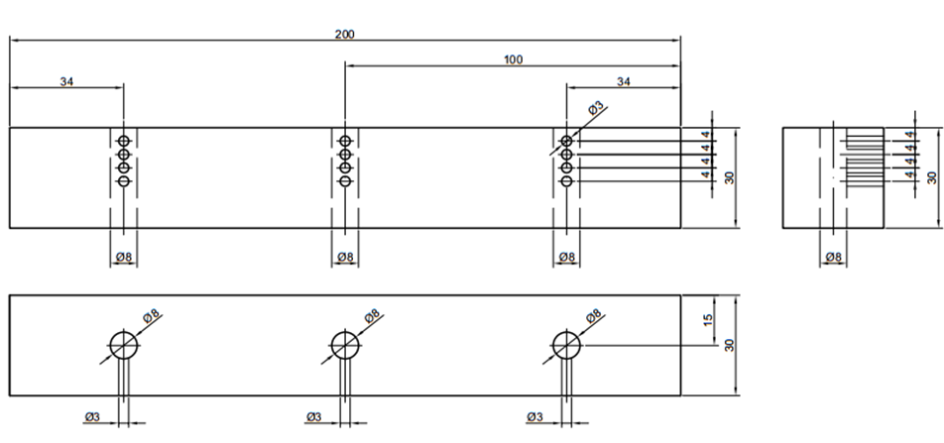
Figure 2. Schematic illustration of the test pine sample for dowel welding

The samples were welded (Figure 3) on a welding machine that can operate in a mode with the dowel rotating. The rotation frequency during the welding process was 1520 min⁻¹. The time needed to weld the dowel on the sample was 4 s, and the clamp time after the welding process was 3 – 5 s. Weld penetration was 20 mm. The dowel was welded to a static sample. A total of 30 samples were welded. Figure 4 illustrates a test sample ready for further testing. A program developed exclusively for this type of study was used during welding. The software recorded current temperature (Figure 5) and depicted it as a graph on a printout in real time. It was developed by M-electronic. Due to some shortcomings of the software, maximum temperatures were read by Acrobat Reader DC with the possibility of error of + 1.5°C. Temperature probes PT1000 with a temperature range of -70 to + 550 °C were used for the test. The probes are Class B with the possibility of error of 0.3%.
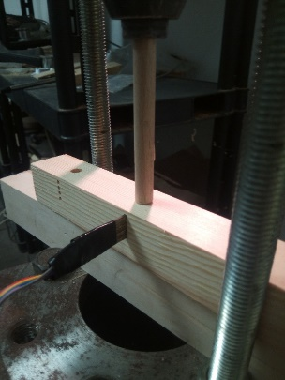
Figure 3. Welding of the test sample

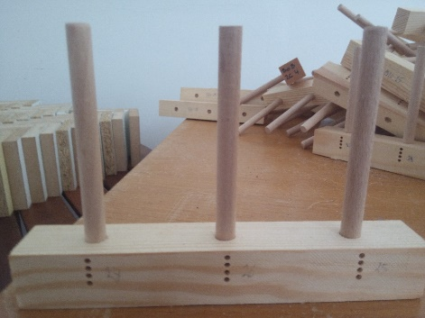
Figure 4. Welded sample

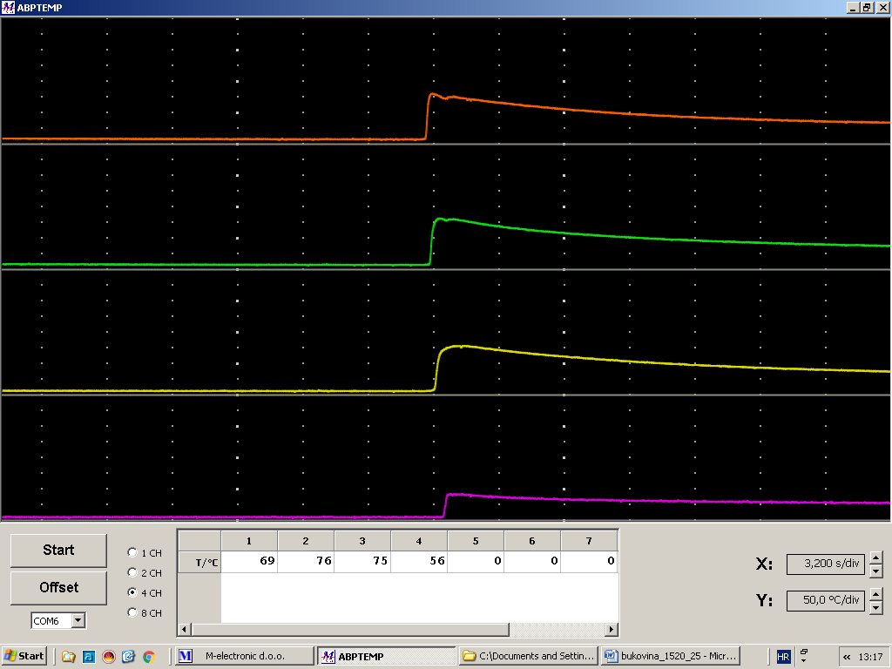
Figure 5. Temperature measuring program

2.1.2. Test Method
After welding, the samples were conditioned (at a temperature of 23 + 2°C and a relative air humidity of 50 + 5%). After that, embedded force was tested on a universal mechanical testing machine Shimadzu AG-X. During the testing, a displacement of 5 mm/min was recorded. Force, displacement and time were measured by a computer so that all values obtained were accurate and precise. Programs Microsoft Excel and Statistica 12 were used to perform a statistical and graphical analysis of the data. Descriptive statistics was used for all analysed variables, and the percentage difference was calculated for some tests. An error of 5% is considered as statistically significant for all statistical analyses. All graphical illustrations of the statistical analysis were made as box plots, while other results were presented in tables. The arithmetic mean and standard deviation were used for parametric tests, and the median and the 25th and 75th percentile for nonparametric tests.

- RESULTS AND DISCUSSION
The study results are presented in Diagram 1 and Figure 6. Welding temperature was measured at four points on the samples along the hole depth. The probe closest to the surface (Probe 1) recorded an average temperature of 184°C due to friction produced as the dowel enters the sample substrate. Probe 2 achieved a statistically insignificant higher average temperature. This increase in temperature is induced by heat transfer from the surface and the dowel (185°C). Probe 4, placed 16 mm away from the surface, recorded the lowest temperature. The reason for the lowest average temperature of 68°C is to be found in the fact that the dowel reduced the tightness due to friction.
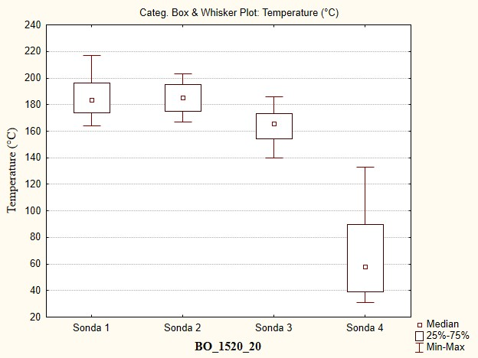
Figure 6. Average temperatures recoded by the probes (BO_1520_20)

Diagram 1 clearly shows the correlation between the rise in temperature and the rise in embedded force, and supports the studies by Kanazawa et al. (2005) and Rodriguez et al. (2010). The average embedded form is 1631 N with a standard deviation of 540.8, and the average maximum temperature is 190°C with a standard deviation of 10.8. The highest temperature was 217°C, and the highest embedded force was 2925 N at 203°C. The trend line allows a conclusion that the embedded force increases with a rise in temperature. The R - quadrant value for the trend lines is 0.193. The value suggests high scattering of data.

Diagram 1. Impact of temperature on embedded force (BO_1520_20)

- THEORETICAL RESEARCH INTO HEATH TRANSFER
The issue of heath transfer from the welding place to the measuring point has been studied by Zoulalian and Pizzi (2007). However, they studied the heath transfer only in the direction of the temperature measuring device (y-axis). Due to the distance between the welding place and the measuring point (in this study it is 2 mm), there occur some losses and the heath transfer from other axes (x-axis and z-axis) to the measuring point. For that reason, a heath transfer model has been developed that takes into account the impact of all axes. The wood welding process is shown in a three-dimensional rectangular coordinate system where the welding process is done along the y-axis (Figure 7). During the process the dowel is in a dynamic contact with each point along the y-axis, represented by 0 ≤ y ≤ y'. For that reason, these points become heath sources. As the time intervals over which the dowel is in contact with each single point along the y-axis differ, so does the intensity of the heath sources. The aim of the study is to formulate an equation to describe the source and the transfer of heath to Point A at which temperature is measured. The said model is a good introduction to the heath transfer issue as it builds upon the heath transfer model by Zoulalian and Pizzi (2007).
Figure 7. Wood welding in a three-dimensional rectangular coordination system. A point at which temperature is measured

5. CONCLUSION
The conducted studies demonstrate that a smooth beech dowel can be successfully welded to a pine substrate (embedded force 2925 N). The study shows that the values of embedded force (joint strength) depend on temperature, supporting, thus, research by Kanazawa et al. (2005) and Rodrigez et al. (2010). It was demonstrated that there is no statistically significant difference in welding temperature between the samples welded at the same frequency and with the same welding penetration (20 mm). The said model is a good introduction to the heath transfer issue as it builds upon the heath transfer model by Zoulalian and Pizzi (2007). Unfortunately, such welded joints have not found wide application due to the complexity of the process, many factors that influence the welding process (welding time, tightness, rotation frequency, wood welding temperature, wood structure and species and the like). Their application is rather insignificant. Therefore, many studies are being conducted in order for the welded joint to find its proper place in the production of furniture.

REFERENCES

Auchet, S., Segovia, C., Mansouri, H.R., Meausoone, P.-J., Pizzi, A., Omrani, P. 2010: Accelerating vs Constant Rate of Insertion in Wood Dowel Welding. J. Adhesion Sci. Technol.,
24 (2010) 1319 – 1328
Kanazawa, F.; Pazzi, A.; Properzi, M.; Delmotte, L.; Pichelin, F. 2005: Parameters influencing wood-dowel welding by high-speed rotation, J Adhesion Sci. Technol., 19 (12): 1025 – 1038
Leban, J.-M., Mansouri, H.R., Omrani, P., Pizzi, A. 2008: Dependence od dowel welding on rotation rate. Holz Roh Werkst, DOI 10.1007/s00107-008-0228-6.
Rodriguez, G., Diouf, P., Blanchet, P., Stevanovic, T. 2010.: Wood – Dowel Bonding by High-Speed Rotation Welding – Application to Two Canadian Hardwood Species. J Adhesion Sci. Technol., 24 (2010): 1423 – 1436.
Zoulalian, A., Pizzi, A., 2007: Wood-dowel rotation welding – a heat – transfer model. J. Adhesion Sci. Technol., 21 (2) 97-108
Župčić, I., Mihulja, G., Bogner, A.,Grbac, I., Horvat, B., 2008: Zavarivanje masivnog drva, Drvna industrija 59 (3) 113 – 119
Župčić, I., Vlaović, Z., Domljan, D., Grbac, I. 2014.: Influence of Various Wood Species and Cross-Sections on Strength of a Dowel Welding Joint. Drvna industrija 65 (2) 121 – 127

