Assessment of influential factors on the geochemistry of the soil-biota system in the Prašnik forest
Maja Ivanić¹, Gordana Medunić², Željka Fiket¹, Gordana Marović³, Jasminka Senčar³, Martina Furdek Turk¹, Goran Kniewald¹
¹ Division for Marine and Environmental Research, Ruđer Bošković Institute, Bijenička cesta 54, Zagreb, Croatia
² University of Zagreb, Faculty of Science, Department of Geology, Horvatovac 95, Zagreb, Croatia (gmedunic@geol.pmf.hr)
³ Institute for Medical Research and Occupational Health, Ksaverska cesta 2, Zagreb, Croatia
The Prašnik forest, located in the south-western part of the Pannonian Basin (Croatia), is a temperate rainforest and the last remnant of the Slavonian rainforest. As a unique phytocoenosis, it was recognized and protected as a special forest vegetation reserve since 1965. Focus of the present study were soil, mushroom and moss samples from this forest. The principal objectives of the study were determination of (i) levels of metals/metalloids in soil, moss and mushroom samples, and (ii) radionuclide activities in soil samples. The main aims of the presented study were to assess: 1) the influence of pedological substrate on the element composition in mosses and mushrooms, as sensitive bioindicators of air quality and environmental health, and 2) the influence of atmospheric deposition on the soil radionuclide composition in this area. Due to its position in the area of warfare during 1990s, the Prašnik rainforest was mined and until 2015 unavailable to visitors. Other than that, as a highly protected area of great biological importance, it was excluded from human exploitation activities since 1928 and is therefore considered free of anthropogenic influence except for contaminants delivered via natural pathways, air or water. Previous studies confirmed only slight and locally restricted influence of the war activities on the soil geochemistry [1], while geochemical composition of both mosses and mushrooms showed prevailing influence of the local substrate [2] and atmospheric deposition [3]. The multielement analysis of soil, moss and mushroom samples was performed by High Resolution Inductively Coupled Plasma Mass Spectrometry (HR-ICP-MS) using an Element 2 instrument (Thermo, Bremen, Germany). All samples, after digestion in the microwave oven (Multiwave 3000, Anton Paar, Graz, Austria), were analysed for total concentration of 28 elements. Radionuclides in the soil samples were analysed gamma-spectrometrically using GMX series gamma-X HPGe and/or Ge(Li) detector (resolution 2.24 keV on 1.33 MeV 60Co, relative efficiency 74.2%; resolution 1.78 keV on 1.33 MeV 60Co, relative efficiency 16.8%). Counting time was 80,000 s or higher and depended on sample activities. Results of the multielement analysis were in agreement with the data reported in European Geochemical Atlas (FOREGS) [4] for this area. Slightly higher levels than expected by the FOREGS were observed only for Cd, Pb and Zn. The calculated bioaccumulation factors (BAF=C_{moss or mushroom}/C_{soil}; C - concentration) suggest slight (BAF=10⁻² – 10⁻¹) to moderate (BAF=10⁻¹ – 1) accumulation of majority of elements (Figure 1) in both mosses and mushrooms (Figure 1). Only Cu in mushrooms exhibited BAF>1. Anthropogenic radionuclides, ¹³⁷Cs and ¹³⁴Cs, were present in all samples and reflect the global contamination of the biosphere caused by nuclear tests and accidents in Chernobyl in 1986 and Fukushima in 2011, respectively (Table 1). Other detected radionuclides are considered to be of natural origin (Table 1).
Figure 1. Average bioaccumulation factors in moss and mushroom samples.
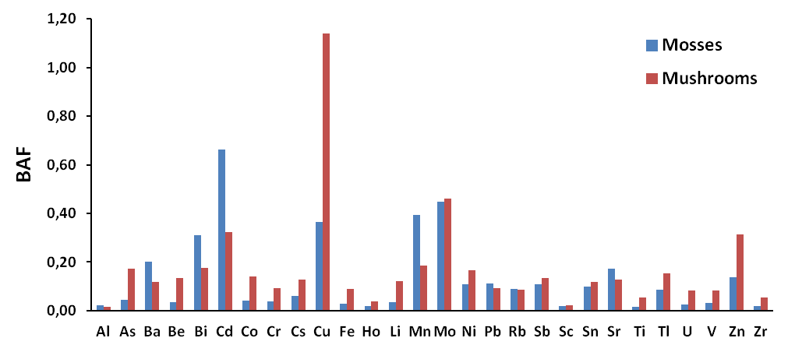

Table 1. Average radionuclide activity concentration in soil samples.
Activity concentration / Bq kg⁻¹
²³⁸U | ²²⁶Ra | ²¹⁰Pb | ²³⁵U | ²³²Th | ²²⁸Ra | ⁴⁰K | ⁷Be* | ¹³⁷Cs | ¹³⁴Cs
66.2 | 44.6 | 55.6 | 2.7 | 42.3 | 42.3 | 542.4 | 13 | 30.8 | 1.6

References
- Mesić Kiš, Ivana; Karaica, Bojan; Medunić, Gordana; Romić, Marija; Šabarić, Jasenka; Balen, Dražen; Šoštarko, Kristijan. Soil, bark and leaf trace metal loads related to the war legacy (The Prašnik rainforest, Croatia). MPGB 31(2) (2016) 13-28.
- Fiket, Željka; Medunić, Gordana; Furdek Turk, Martina; Ivanić, Maja; Kniewald, Goran. Influence of soil characteristics on rare earth fingerprints in mosses and mushrooms: example of a pristine temperate rainforest (Slavonia, Croatia). Chemosphere 179 (2017) 92-100.
- Medunić, Gordana; Marović, Gordana; Senčar, Jasminka. Radionuclides in soil, mosses, and mushroom of the Prašnik rainforest (Croatia) Geologica Macedonica - zbornik na trudovi (2016) 451-452.
- Salminen, R. (Chief Editor) et al. FOREGS Geochemical Atlas of Europe, Part 1: Background Information, Methodology and Maps. (2005) Available online at: http://www.gtk.fi/publ/foregsatlas/

