Impact of Distributed Generation on Power Quality in Distribution Network
Experience from Eastern Croatia
Zvonimir Klaić, Mario Primorac, Danijel Topić, Goran Knežević
Faculty of Electrical Engineering, Computer Science and Information Technology Osijek
Osijek, Croatia
zvonimir.klaic@ferit.hr, mario.primorac@ferit.hr, danijel.topic@ferit.hr, goran.knezevic@ferit.hr

Abstract— Power quality can be affected by various types of renewable energy power plants (REPP) such as photovoltaic power plants, wind power plants, fuel cells, solid biomass, biogas or biodiesel power plants. Various interface technologies by which these power plants are connected to the power grid have a different impact on the power quality. Potential impacts of particular types of power plants with renewable sources on the power quality are described in detail in the literature. Their influence on the power quality can be predicted by simulations but the actual impact can be determined only by measuring after construction and connection of the observed power plant.
In this paper, the impacts of biogas power plants and PV power plants on the power quality in distribution network in Eastern Croatia are presented and analyzed. All the analyzes are based on actual measurements that are performed in the last ten years by Laboratory for Electromagnetic Compatibility, Department of Power Engineering, Faculty of Electrical Engineering, Computer Science and Information Technology Osijek (FERIT).
Keywords— Distributed Generation; Power Quality; Distribution Network; Eastern Croatia

Introduction
The number of installed REPP, as well as other distributed sources, is increasing every day. According to [1] total installed capacity of renewable power (excluding large hydropower plants) at the end of 2016 was 921 GW. The total installed capacity of renewable power in 2006 was 207 GW [2]. If we compare 2016 with 2006 total installed capacity of renewable power increased 3.41 times in the 10-year period. In Croatia, at the end of 2015 the total installed capacity of renewable power was 525.7 MW and generated electricity from renewable power in 2015 was 1135.8 GWh [3]. Wind power plants take the largest share with 418 MW, then solar power plants (PV) with 47.8 MW, then biogas and biomass thermal power plants with 27.2 MW and 24.6 MW and then small hydropower plants with 6.3 MW [3].
Each of the mentioned sources, with regard to the type and technology, contributes to the power quality in the power system. The literature describes in detail the potential impact of certain types and technologies of REPP on the power quality: photovoltaic power plants, wind power plants, fuel cells, generators and turbines using different propellant fuels (gas, diesel) [4, 5]. However, the impact of a particular power plant depends not only on its technology or type but also depends on the parameters of the power grid at the connection site. Although most of the future power plant's impact on the power grid can be predicted by simulations using modern software packages, the final status confirmation is measurements after the construction of a power plant. Measurements are performed during 7 days before connection and during 7 days after connection of the distributed source. The results are analyzed and compared to the applicable standards and regulations - HRN EN 50160 and Croatian Grid Code.
The influence of REPP on power quality of distribution network is described in the second chapter of the paper. The possible influences of synchronous machines and electronic converters are given in detail. Third chapter contains information about total installed capacity in renewable power plants by July 2018 in Eastern Croatia, and fourth chapter consists of detailed analysis of power quality measurement results during the last 10 years: 9 biogas power plants and 7 photovoltaic power plants.

Influence of REPP on power quality of distribution network
Although power conversion technology has a certain role in the power quality (such as wind and sun due to power changes may cause voltage fluctuations), the power quality is mostly dependent on the interface and connection of the distributed generation and the type of connection with the electric power system, [4].
Main types of interface and system connections are synchronous machines, asynchronous (induction) machines and electronic converters. Since there are no power plants with asynchronous (induction) machines in Eastern Croatia, their influence on the power quality will not be discussed in this paper.

Synchronous machines
Although synchronous machines are well-known technology in the power system, there are some challenges when they are used as distributed sources. Due to their inertia, they can well tolerate leaps in the system, which is good when they are used as a reserve energy source. In the case of their application as distributed sources, they would be able to easily handle the island operation but also supply short circuit, [4].
Synchronous generators usually do not increase the number of voltage dips. The only possible impact is the voltage dip due to the connection of the generator to the grid. This is of concern only for a generation with rotating machine interface, and even in this case, typically a soft starting is used to limit the voltage drop [5].
The standard way of designing the winding of synchronous machines causes a relatively large third harmonic voltage in the amount of about 10% of the fundamental component, whereas the fifth and seventh harmonic voltages are around 1% [6]. By connecting the generator on the grid through a delta-wye connected transformer, the third harmonic will not be transmitted to the grid. However, if the generator is connected directly to the low voltage grid or through wye-wye connected transformer, the third harmonic distortion may spread through the system. Although small distributed sources do not have enough power to regulate the voltage in the system, there is the possibility that the synchronous machine is large in relation to the system's capacity and it is involved in regulating the voltage of the power system. Of course, this contributes to the better power quality in some weak systems. However, these cases should be carefully studied and then carefully aligned with the protection and regulation of the network voltage.
In Croatia, synchronous generators are mostly used in biogas plants and biomass power plants. The main raw materials for propulsion are located near farms (predominantly cow farms) and near the woods, power plants are built in rural areas. Synchronous generators are commonly connected on middle voltage power network through three-phase transformers that have delta-wye windings connection. For distribution networks in rural areas it is characteristic that they are "weak", i.e. there is usually no significant consumption. Therefore, with carefully adjusted protection, problems with voltage regulation can be expected - so it is important to keep in mind that the voltage, with the connected power plant, is not too high. So far, this challenge has been solved mainly by the manual regulating voltage on the transformer. In the normal operation of such power plants, problems with other indicators of the power quality are not expected.

Electronic converters
All distributed source technology that produces DC or AC power with other than network frequency, must be connected to the power grid via an electronic converter. Although electronic converters have an undeniable influence on the power quality, in the form of higher harmonics current, the newer pulse-width modulation technology brings significant improvements [4]. Depending on the type of AC output waveform, the used power topologies can be voltage source converters where controlled AC output is a voltage waveform. Alternatively, current source converters control the AC output current waveform [7]. Multilevel converters are used because as the number of levels is higher, the harmonics are lower. The most used multilevel converter topologies are neutral-point clamped (NPC), flying capacitor converter (FC) and cascaded H-bridge converter (CHB). According to [8], if these three types of topologies are compared, NPC has the highest efficiency and the lowest total harmonic distortion.
In the case when converters are interconnected to the utility, they basically attempt to produce a sine-wave current that follows the voltage waveform. In this way, power factor equals 1. The ability of converters to feed utility-side faults is usually limited by the maximum current capability of the IGBT switches. It is assumed that the current will be limited to 2 times the rated output of the converter. Once the current reaches these values, the inverter will assume a fault and stop the operation for a predetermined time [4]. In the photovoltaic power plant, the most important part, considering power quality is a converter that converts the direct current from photovoltaic modules into alternating current, [9]. The converter has several functions and the first is to control the photovoltaic route. When the sun rises in the morning, the photovoltaic module is connected to the network. As insolation and temperature change during the day, the converter adjusts the current and voltage to maximize the power output from the photovoltaic modules. At the end of the day, the converter disconnects the system from the network.
According to [10], several low order harmonic amplitudes increase when PV inverter output power decrease. The current THD becomes higher at a low power output level, especially for generated power below 20% of the rated power. It is concluded that DC-link voltage variation due to maximum power point tracking (MPPT) is the major cause of the harmonic amplitude increase. According to [11], measurements show that currents of higher harmonics are injected by the power plant mainly in the morning after the power plant is connected to the grid and in the evening before the disconnection of the power plant. The harmonics are also present in times of severe falls in production (changes in sunlight).

Renewable Energy Sources in Eastern Croatia
Eastern Croatia covers five counties: Osijek-Baranya (OBŽ), Vukovar-Srijem (VSŽ), Požega- Slavonia (PSŽ), Virovitica-Podravina (VPŽ) and Brod-Posavina (BPŽ) County. Total installed capacity in renewable power plants by July 2018 in Eastern Croatia is 79.42 MW. Total installed capacity is: in the biomass power plants 28.45 MW, in biogas power plants 23.59 MW, in photovoltaic power plants 14.06 MW, in cogeneration power plants 12.8 MW and in small hydropower plants 0.52 MW, respectively.

- Installed capacity of REPP in Eastern Croatia.

Analysis of Power Quality Measurement Results
Power quality measurements are performed according to IEC 61000-4-30 and EN 50160 standards, by power network analyzers, accuracy class A. The results of Power quality measurements are analyzed separately, according to EN 50160, and according to Croatian Grid Code. European standard EN 50160 gives the main characteristics of the voltage characteristics, supplied by the public distribution system, at the customer’s supply-terminals. According to this standard, each measurement lasts seven days and includes indices: voltage dips and interruptions, harmonics and interharmonics, temporary overvoltages, swells, transient overvoltages, voltage fluctuations, voltage unbalance, power-frequency variations, DC in AC networks, Signaling voltages. Analysis of power quality measurements according to the Croatian Grid Code also include limits for voltage fluctuations and frequency variations, and their limits are similar to those in EN 50160. But it gives limits for the allowed contribution of the power plant on distribution network for: THD_{U} (Total Harmonic Distortions of Voltage), flickers and voltage imbalance. Because of the latest conditions, analysis of power quality measurements before and after the connection of power plants on the distribution grid is performed.

Biogas Power Plants
During the last 10 years (from 2008) power quality measurements on 9 biogas power plants in Eastern Croatia were performed by FERIT. Table I shows summarized measurement results for every power plant, and for each power quality index – voltage variations, voltage events, harmonics, flickers, voltage unbalance and line frequency. Measurements lasting 7 days were performed first before and then after the connection of each biogas power plant. All measurement results showed that power quality indices were in accordance with European norm EN 50160 and Croatian Grid Code. In the Tables I and II, mark “+” means that the index has been improved after connecting the power plant, and mark “-“ means that the index was worse after connecting the power plant. A cell without a mark means that a certain power quality index was very similar before and after the connection of the power plant. Table I shows that there were particular worsening in 5 power plants: voltage variations were worse in BIO5, voltage events in BIO2, harmonics in BIO3, unbalance in BIO9, and flickers were worse in BIO2, BIO3, BIO4, and BIO9. Slightly higher values of voltage at the connection point of BIO5 were recorded only on the first day of measurement week, and after planned network reconfiguration, values were very similar to those before connection of BIO5. Although 78 swells and 13 voltage dips were recorded at the connection point of BIO5, all events happened in only two very short periods (in a few minutes). They were not uniformly distributed over the week, so obviously, they were two isolated voltage instabilities. Flickers, as power quality index, stands out in Table I: higher flicker values after power plant connection were recorded in four cases.
- Results of Power Quality Measurements – Biogas Power Plants
Facility name | Nom. Power  [kW] | Voltage  variation | Events | Voltage  harmonics | Flicker | Unbalance | Line  frequency
BIO1 | 1000 | + | + | + | +
BIO2 | 1000 |  | - |  | -
BIO3 | 300 |  | + | - | -
BIO4 | 1400 | + | + |  | -
BIO5 | 1700 | - | + | + | +
BIO6 | 1000 | + | + | + | +
BIO7 | 1000
BIO8 | 1000 | + |  | + | + | +
BIO9 | 1000 |  |  | + | - | -

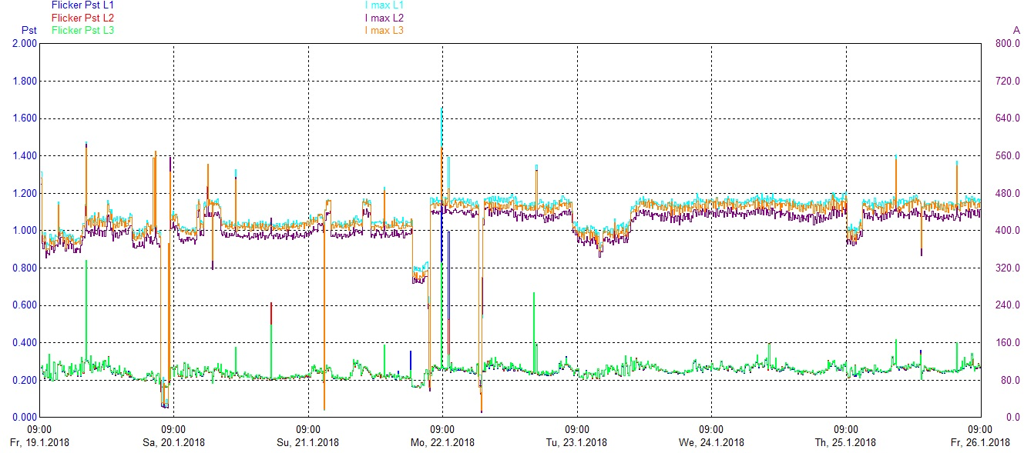
- Short term flickers P_{st} and maximum values of current I_{MAX} – BIO3

Figure 2 shows short-term flickers P_{st} and maximum values of current I_{MAX} measured at the connection point of 300 kW biogas power plant BIO3. Most of the flicker values during the measurement week were below P_{st} = 0.4. Also, some short-term flicker peak values happened simultaneously as biogas power plant current changes, but all of them, and consequently long-term flickers, had values below P_{lt} = 1. Similar results were also recorded at the connection points of BIO9 and BIO2. The only difference is that there were higher values of short-term peak value flickers, so one exceeded the value of the European norm EN 50160 (P_{lt} = 1) was recorded at the BIO9 and three exceeded values were recorded at BIO2, Figure 3.
Measurement results at the BIO4 show that there was a certain flicker contribution during all measurement week. By comparing the short term flicker values before and after the connection of BIO4 it can be noticed that the values after connection are somewhat higher than before. Before connecting the power plant most of the values went around P_{st} = 0.2 with twenty prominent jumps, of which 2 values were above P_{st} = 1. After connecting the power plant it can be noticed that most values were moving around P_{st} = 0.5 with a dozen expressive jumps, of which 4 values were above P_{st} = 1.

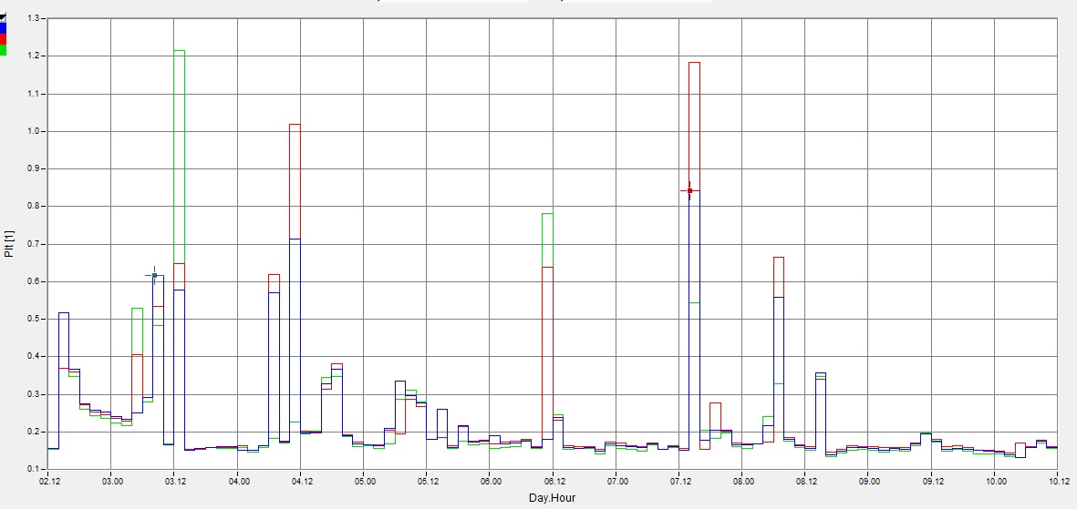
- Long term flickers P_{lt} – BIO2
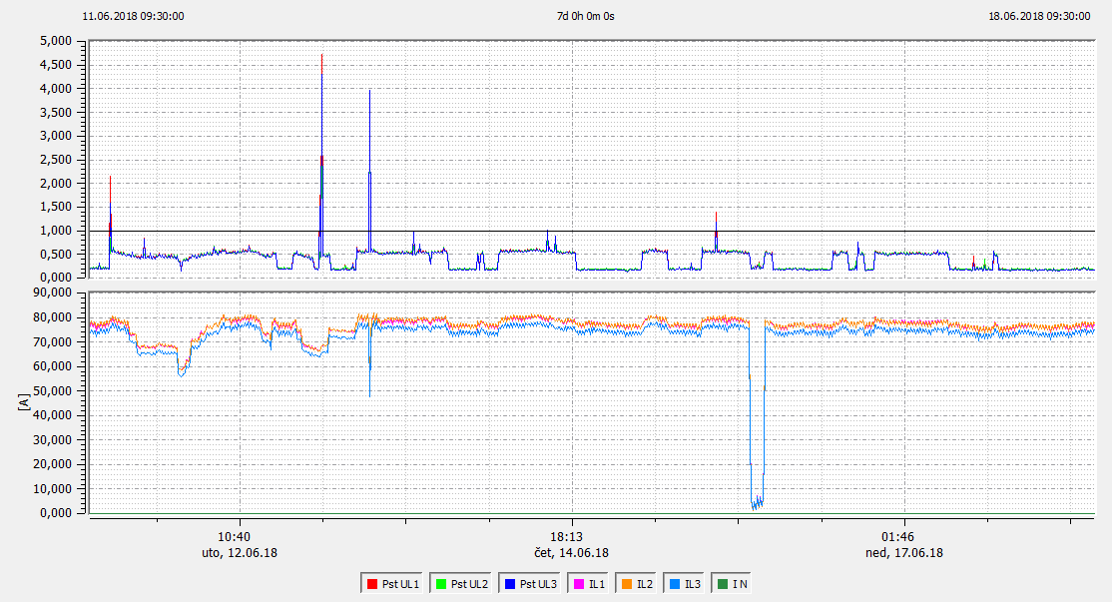
- Short term flickers P_{st} and averaged 10-minute effective current values – BIO4
According to Figure 4 (where short-term voltage flicker and averaged 10-minute effective current values are shown) it can be concluded that values of short-term flicker (P_{st} = 0.5) were caused by power plant operation. But since the contribution of the power plant to the short term flicker were below the value of P_{st} = 0.7 (the contribution mostly moves around P_{st} = 0.3) it is clear that BIO4 has allowed contribution of short-term flickers according to the Croatian Grid Code. Consequently, a similar conclusion applies to long-term flickers.

Photovoltaic Power Plants
During the last 7 years (from 2011) power quality measurements on 7 PV power plants were performed. Table II shows summarized measurement results for every PV power plant, and for each power quality index. Same as with biogas power plants, measurements were performed before and after the connection of each PV power plant.
Table II shows that there were some worsening in 4 power plants: index voltage variations were worse in PV5, and flickers were worse in PV1, PV3, and PV7. It is possible that PV5 is responsible for slightly higher voltage in low voltage distribution network because 30 kWp PV power plant PV5 is connected to 400 V distribution network. Regarding flickers in PV1, PV3 and PV7, further analysis shows that PV power plants mainly did not cause it.
Figure 5 shows short-term flickers P_{st} and maximum values of current I_{MAX} measured on 300 kWp PV power plant PV7. Most of the flicker values during the measurement week were below P_{st} = 0.2 and although some peak values were caused by changes in PV production, most of them were happened when PV was inactive. The very similar situation was on PV3 – most of the recorded flickers were caused by events from power network.
It is interesting that there was no harmonic worsening in any PV power plant measurement. However, a deeper analysis of the measurement results in several measurement periods has shown that changes in sunlight have no effect on the voltage harmonics recorded at the connection point of the photovoltaic power plant. The recorded data show that there is no correlation between the voltage harmonics and the production of the photovoltaic power plant, Figure 7. Here the facts mentioned in [10] and [11] are confirmed.
On the other side, Figure 6 shows a different situation on 30 kWp PV power plant PV1. Most of the flicker values during the measurement week were also low – below P_{st} = 0,3 but almost all peak values were caused by fast changes in production, which were caused by insolation changes. Nevertheless, all measured values were in accordance to EN 50160 and Croatian Grid Code.

- Results of Power Quality Measurements – PV Power Plants
 | PV POWER PLANTS
Facility name | Nom. Power  [kW] | Voltage  variation | Events | Voltage  harmonics | Flicker | Unbalance | Line  frequency
PV1 | 30 |  |  |  | -
PV2 | 10 | + | + | + | +
PV3 | 200 |  |  |  | -
PV4 | 10 |  | + |  | +
PV5 | 30 | -
PV6 | 30 |  |  |  | +
PV7 | 300 |  |  |  | -

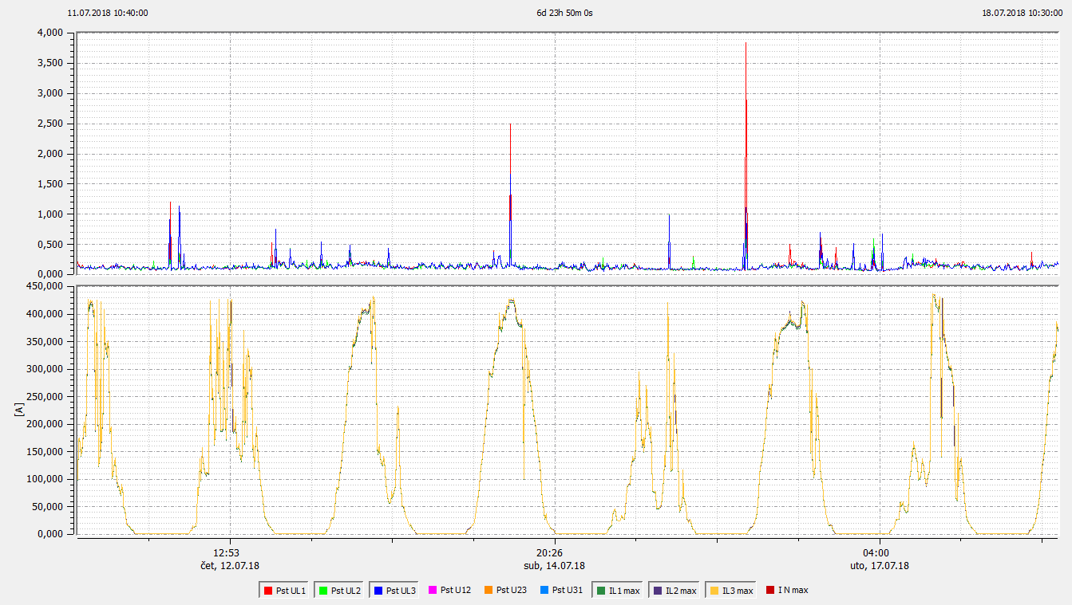
- Short term flickers P_{st} (upper diagram) and maximum values of current I_{MAX} (lower diagram) – PV7
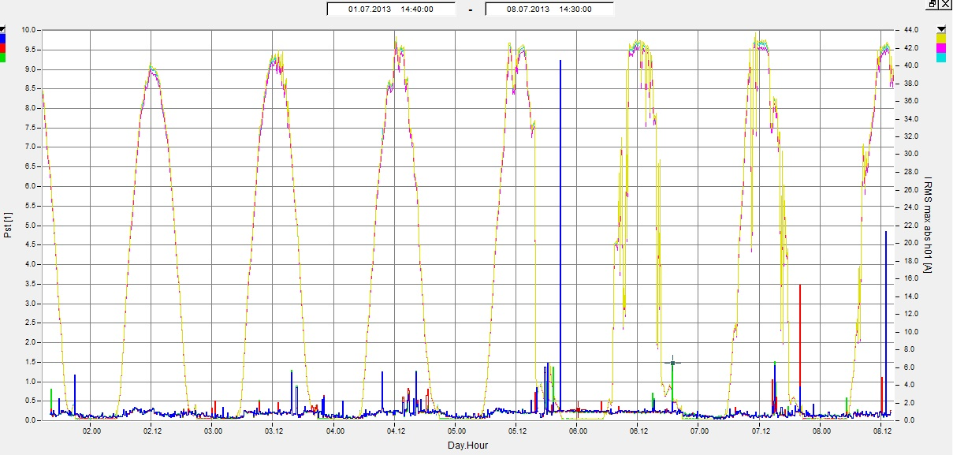
- Short term flickers P_{st} and maximum values of current I_{MAX} – PV1

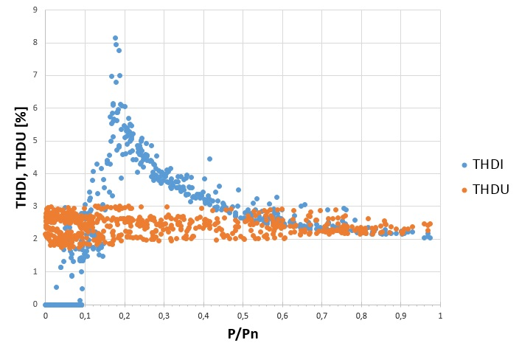
- THD_{I} and THD_{U} in different production conditions of PV5.

Conclusion
In this paper, the impacts of different types of REPP on the power quality in distribution network in Eastern Croatia are presented and analyzed. In comparison with PV power plants, biogas power plants have a larger impact on distribution network which can be seen from Tables I and II. Biogas power plants BIO2, BIO3 and BIO4 are connected to the weak grid where the load is very low and that is the reason why they are contributing to increasing of flickers. Generally, there is no negative influence of renewable power plants in eastern Croatia on power quality of distribution grid. All power quality indices are in allowed limits.

Acknowledgements
This research is part of the RuRES, HUHR /1601/3.1.1/0033 project financed in frame of Interreg V-A Hungary-Croatia Co-operation Programme 2014-2020.

References
- “Renewables 2017 Global Status Report” (Paris: REN21 Secretariat), http://www.ren21.net/wp-content/uploads/2017/06/17-8399_GSR_2017_Full_Report_0621_Opt.pdf, last access on 16.1.2018.
- “Renewables 2007 Global Status Report” (Paris: REN21 Secretariat and Washington, DC: Worldwatch Institute). Copyright © 2008 Deutsche Gesellschaft für Technische Zusammenarbeit (GTZ) GmbH. http://www.ren21.net/Portals/0/documents/activities/gsr/RE2007_Global_Status_Report.pdf, last access on 16.1.2018.
- Energija u Hrvatskoj 2015., Godišnji energetski pregled, MINISTARSTVO ZAŠTITE OKOLIŠA I ENERGETIKE, Republika Hrvatska, Energetski institut Hrvoje Požar Zagreb, Savska cesta 163, 2016.
- R.C. Dugan, M.F. McGranaghan, S. Santoso, H.W. Beaty, Electrical Power Systems Quality, The McGrew-Hill Companies, New York, 2002.
- M. Bollen, F. Hassan, Integration of distributed generation in the power system, John Wiley & Sons, Inc., Hoboken, New Jersey, 2011.
- G.J. Wakileh. Harmonics in rotating machines. Electric Power Systems Research, 66(1):31–37, 2003.
- A.F. Zobaa, S.H.E. Abdel Aleem, Power Quality in Future Electrical Power Systems, The Institution of Engineering and Technoilogy, London, UK, 2017.
- A. Delavari, I. Kamwa, A. Zabihinejad, A Comparative Study of Different Multilevel Converter Topologies for High Power Photovoltaic Applications. 7th Power Electronics, Drive Systems & Technologies Conference (PEDSTC 2016), Tehran, Iran, 2016.
- A.B. Baggini: Handbook of Power Quality, John Wiley and Sons, UK, 2008.
- Y. Du, D. D. Lu, G. James, D.J. Cornforth, Modeling and analysis of current harmonic distortion from grid connected PV inverters under different operating conditions. Solar Energy, 94:182-194, 2013.
- K. Fekete, Z. Klaić, LJ. Majdandžić. Expansion of the residential photovoltaic systems and its harmonic impact on the distribution grid, Renewable energy, 43, 2012

